1. Creating Virtual Machine

* Open the Oracle VM VirtualBox Manager.
* Click new button at the top.
* Set your Virtual Machine name. The name will be used for the VM’s files on disk.
* Set the Operating Stype into “Linux”.
* Set version into “Ubuntu(64bit)”.
* Click next.

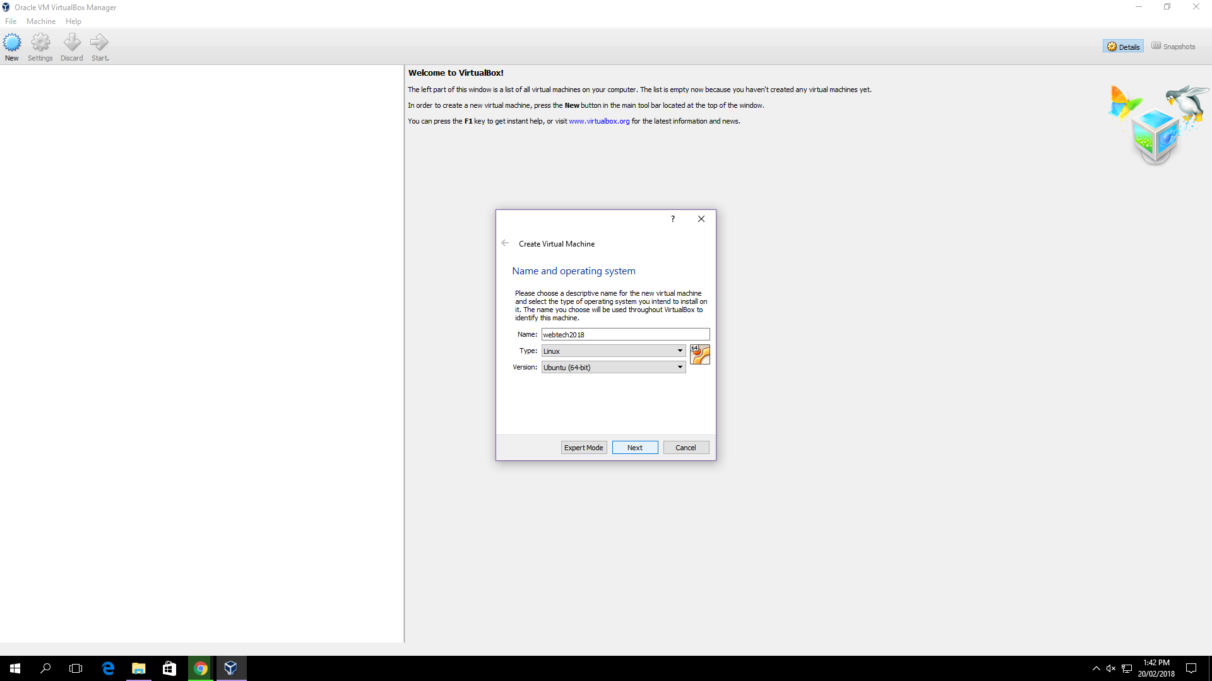

Image 1.1

* Select the memory RAM and choose a memory size.
* Next, it must be specify a virtual hard disk for the VM.
* Choose VDI for the hard disk file type.

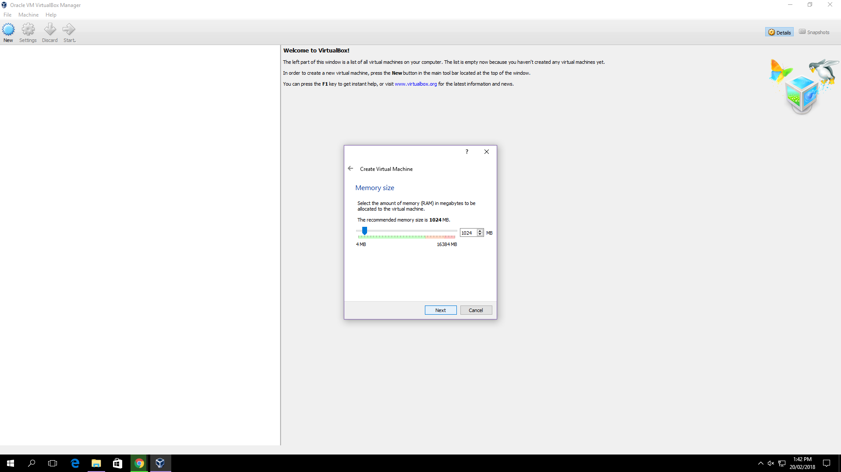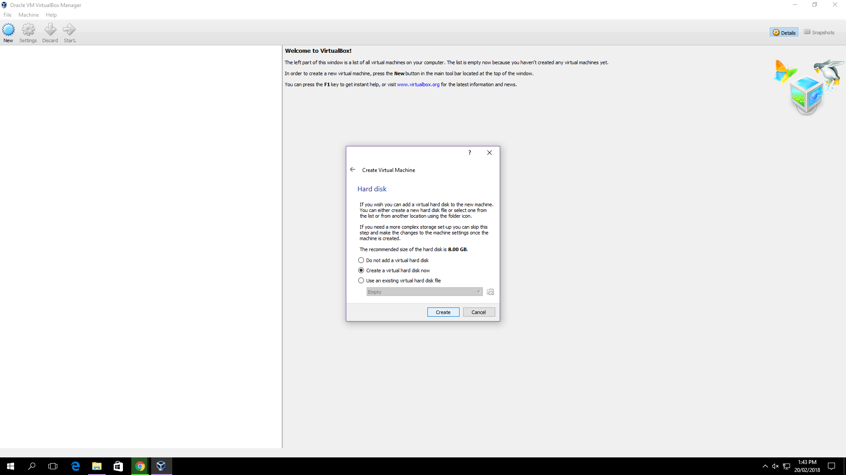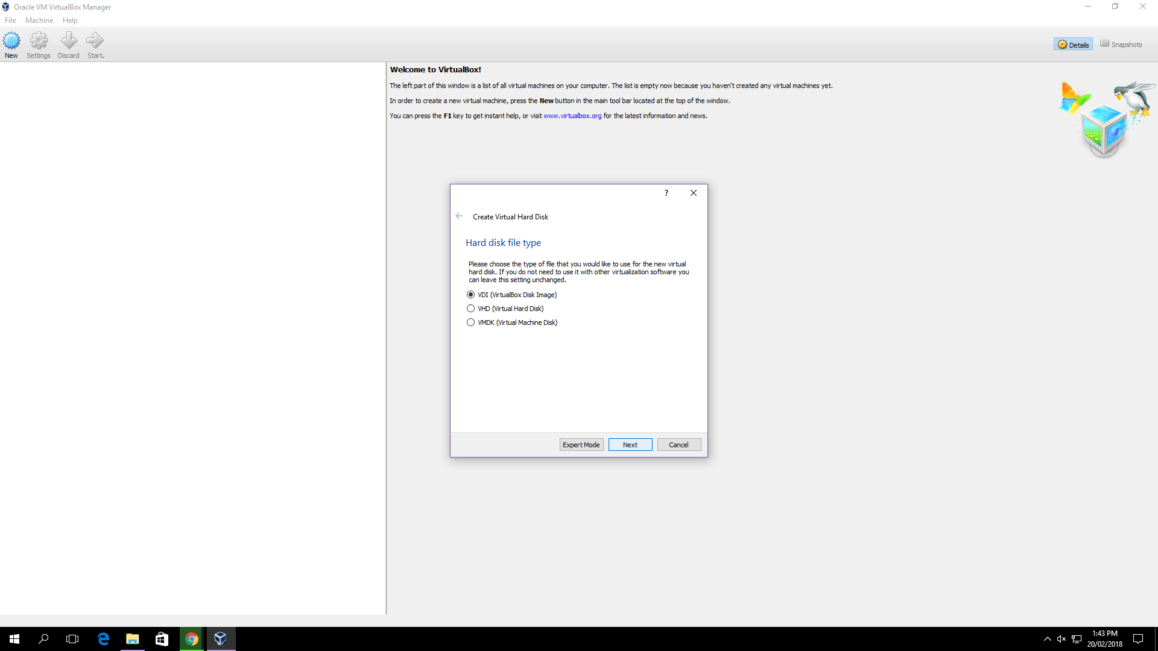

Image 1.2 Image 1.3 Image 1.4

* Choose dynamically allocated so that it will only grow later to size specified as it is filled with data.
* A fixed-size file will occupy the file specified. While occupying much more space, a fixed-size file incurs less overhead and is therefore slightly faster than a dynamically allocated file.

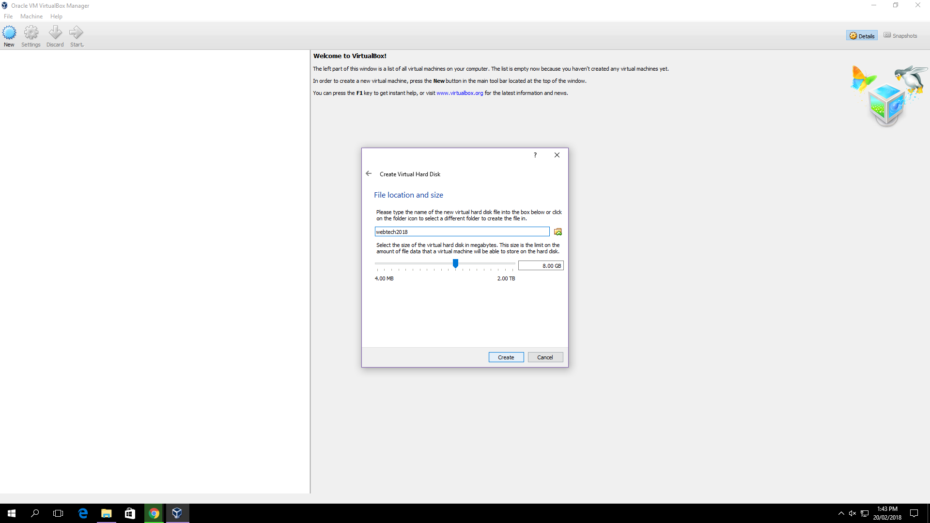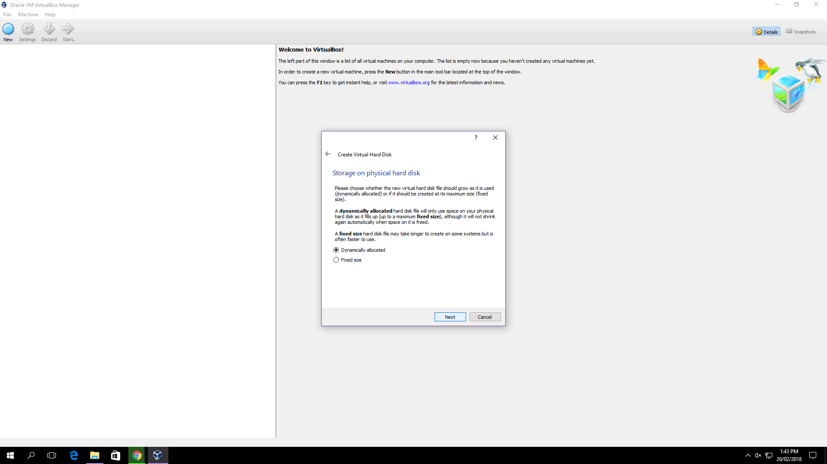

Image 1.5 Image 1.6

2)Starting a new VM

* Go to the settings and go to the storage
* Add an Optical Drive.
* Find the ubuntu file that was downloaded.
* Click ok.

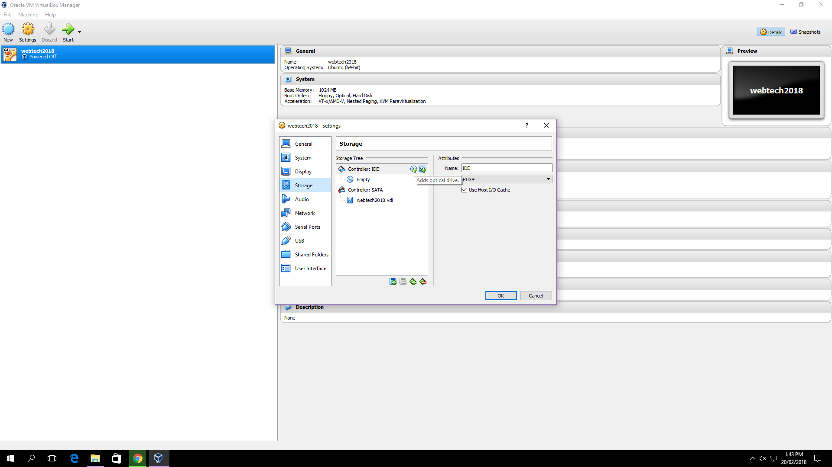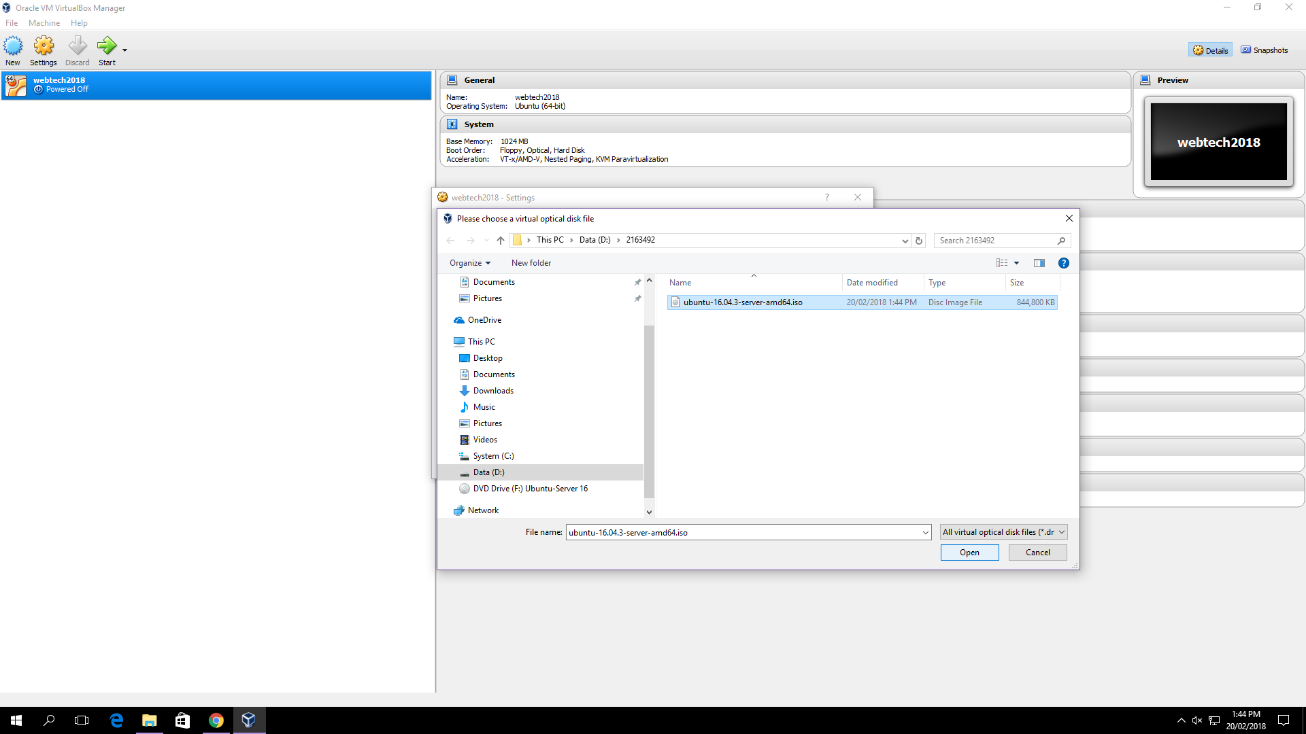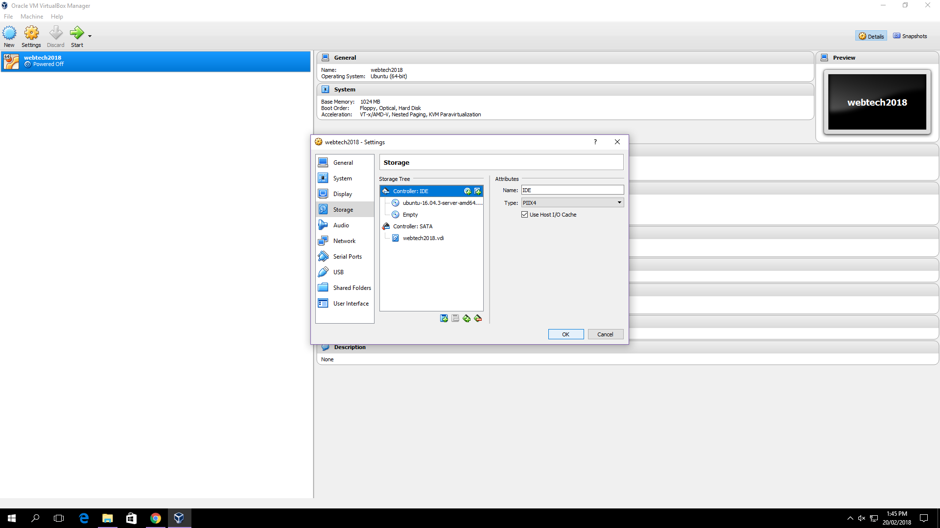

Image 2.1 Image 2.2 Image 2.3

3) Installation

* Select language
* Install Ubuntu Server 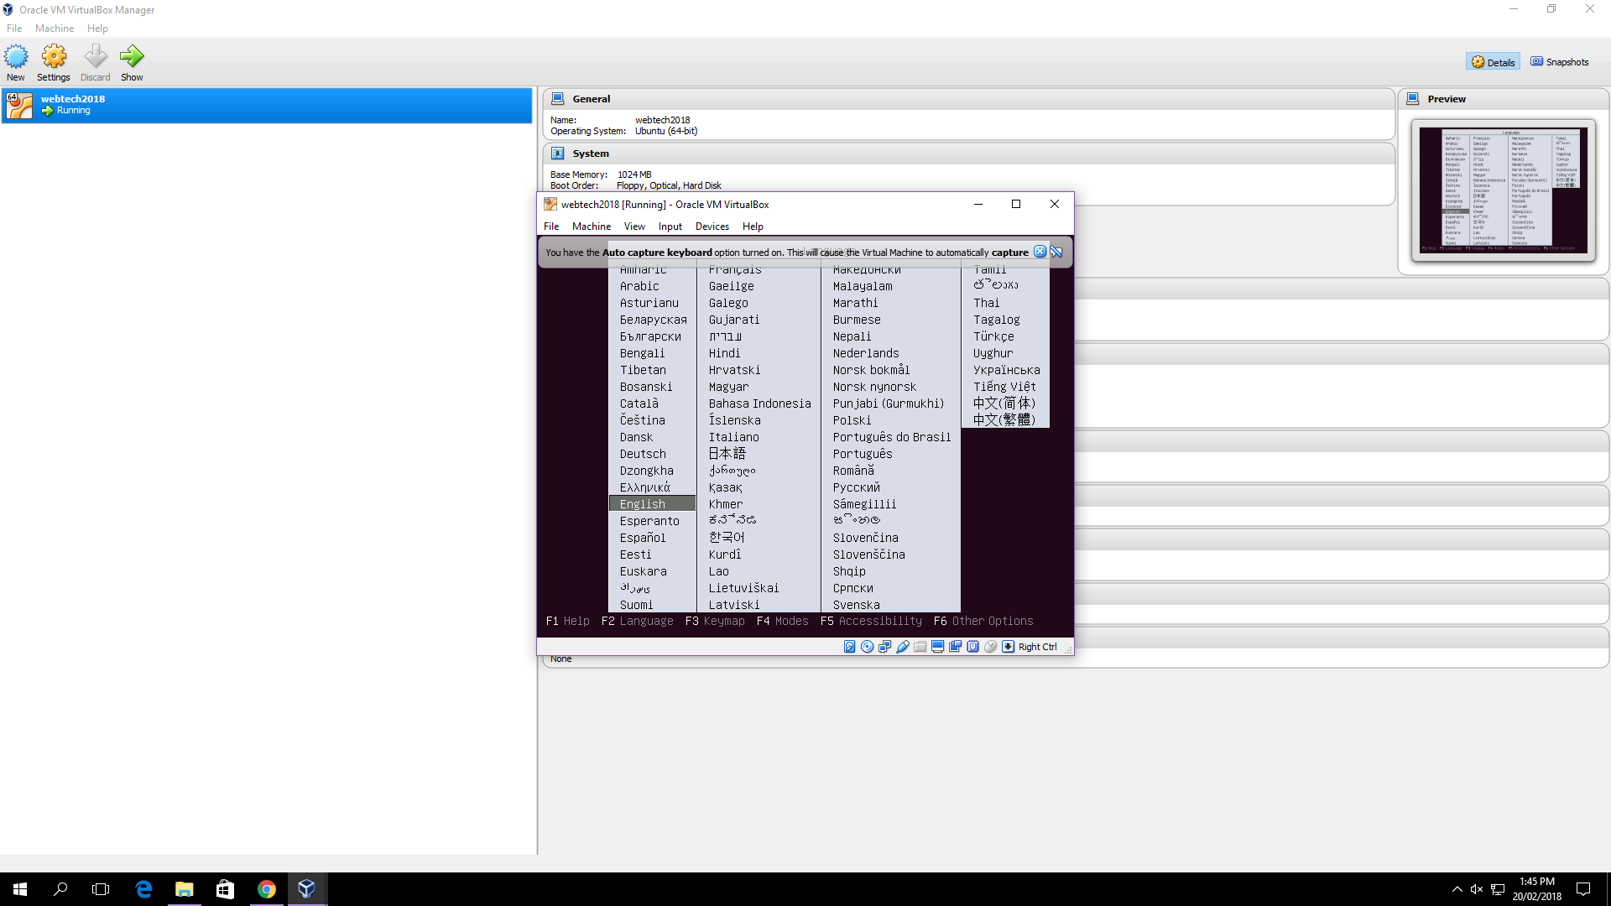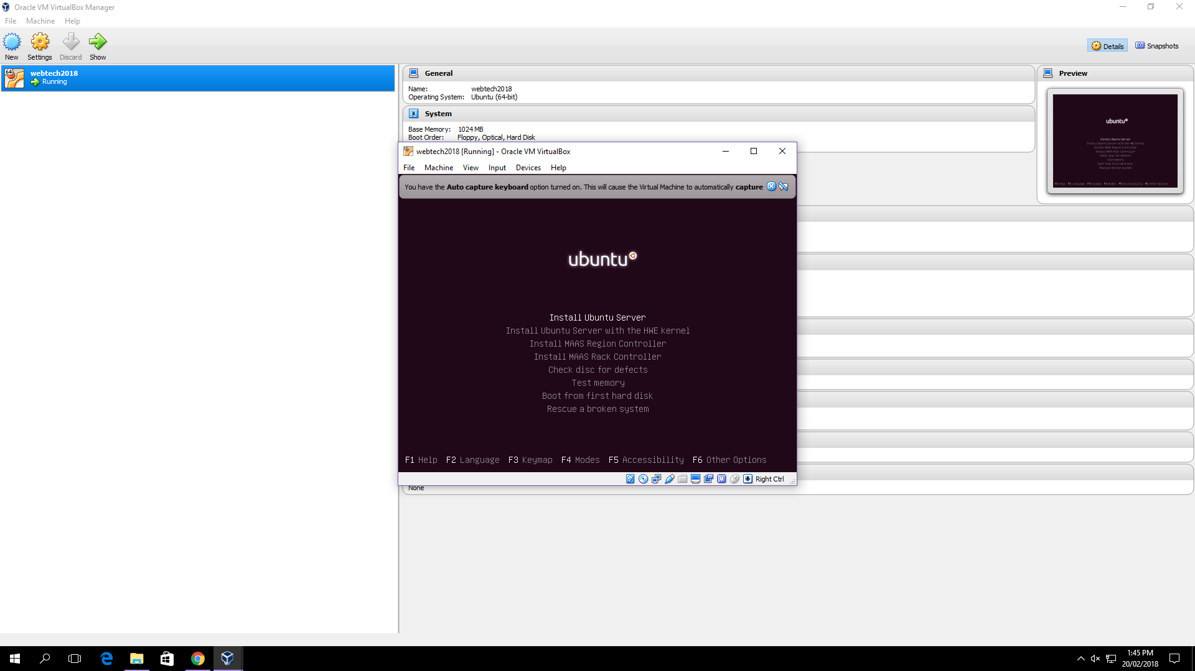

Image 3.1 Image 3.2

* Select language
* Choose location

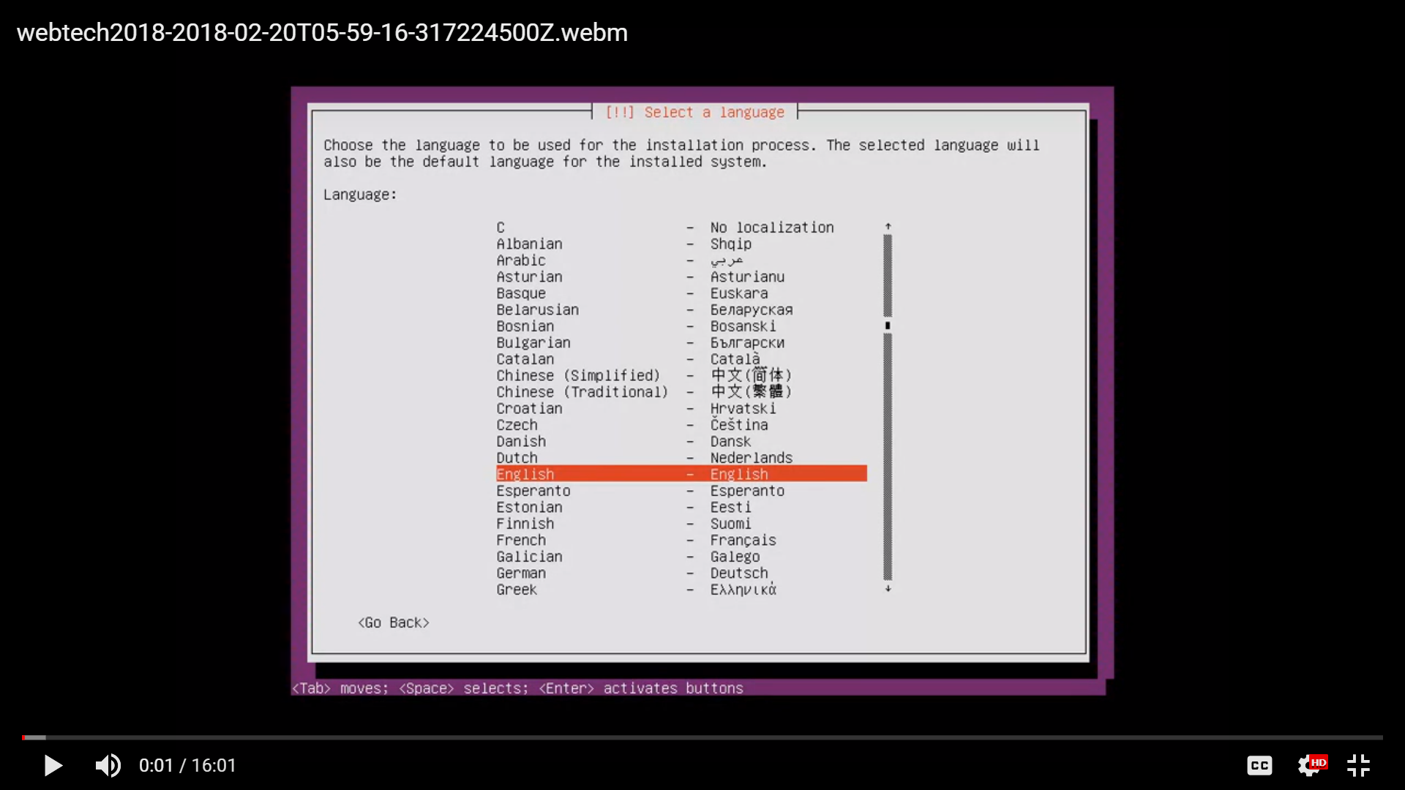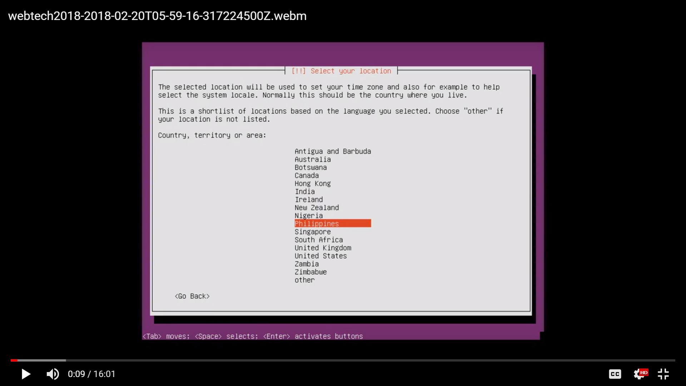

Image 3.3 Image 3.4

* Setting up keyboard layout.
* Checking of keys.
* Press the one key that your keyboard have.
* Choose “yes” if your keyboard can detect and “no” if can not.

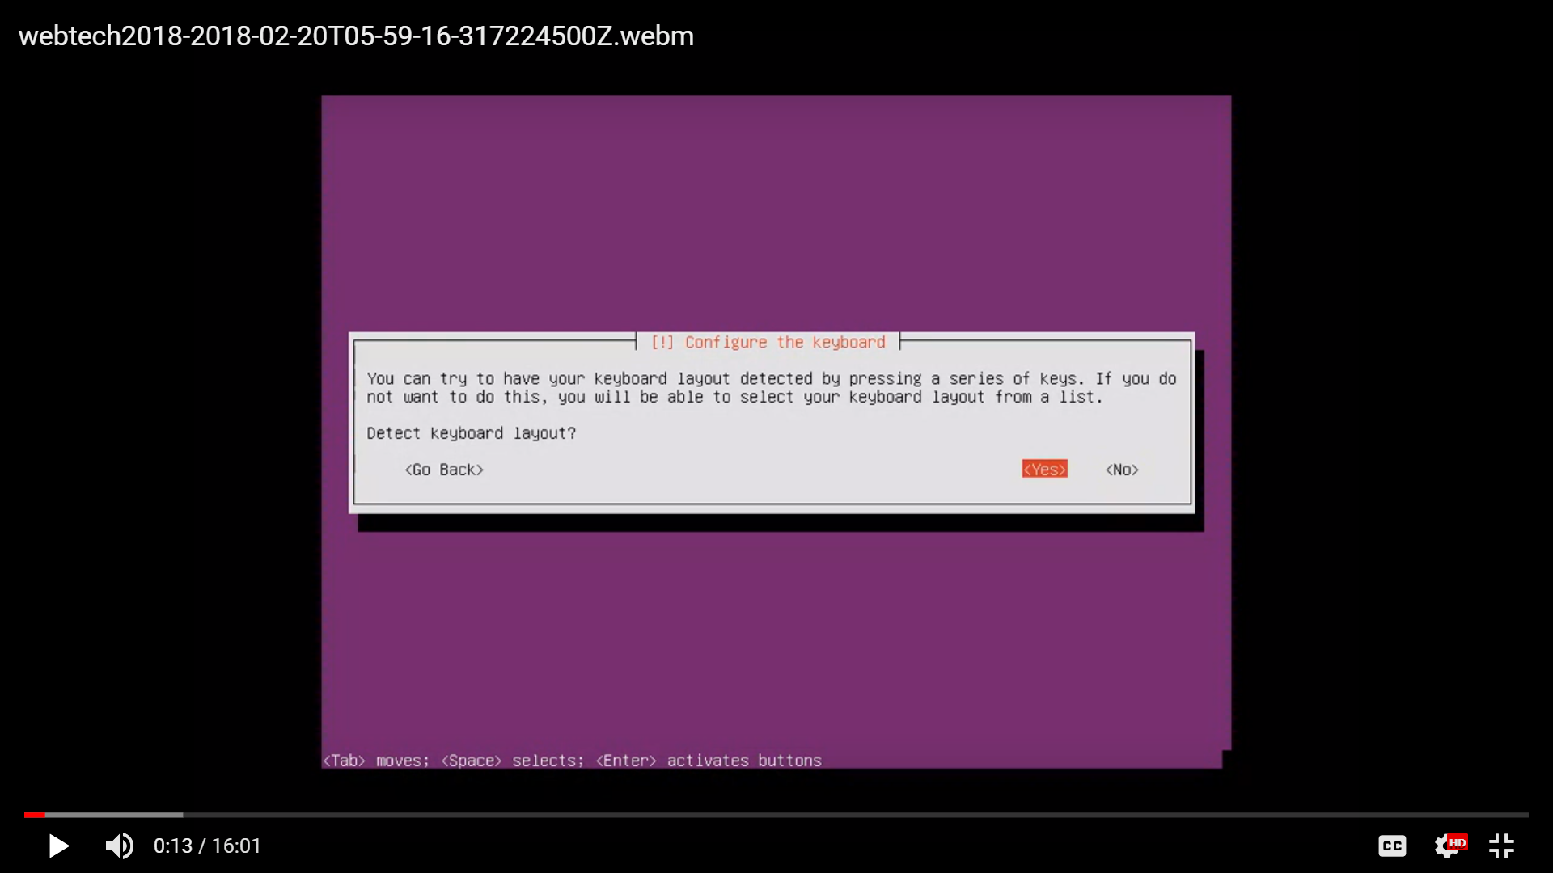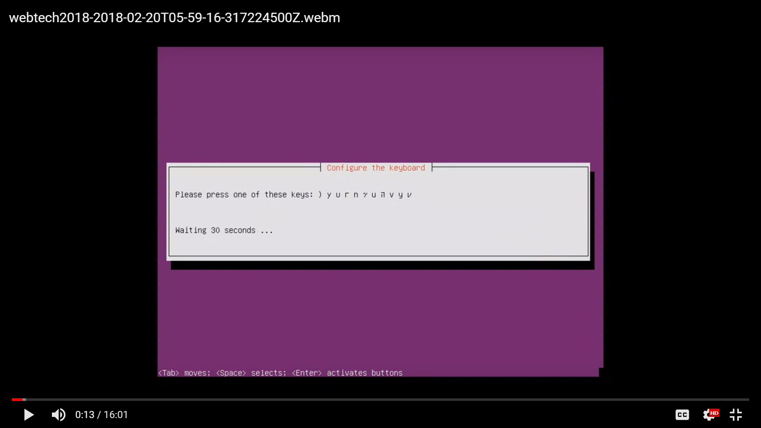

Image 3.5 Image 3.6

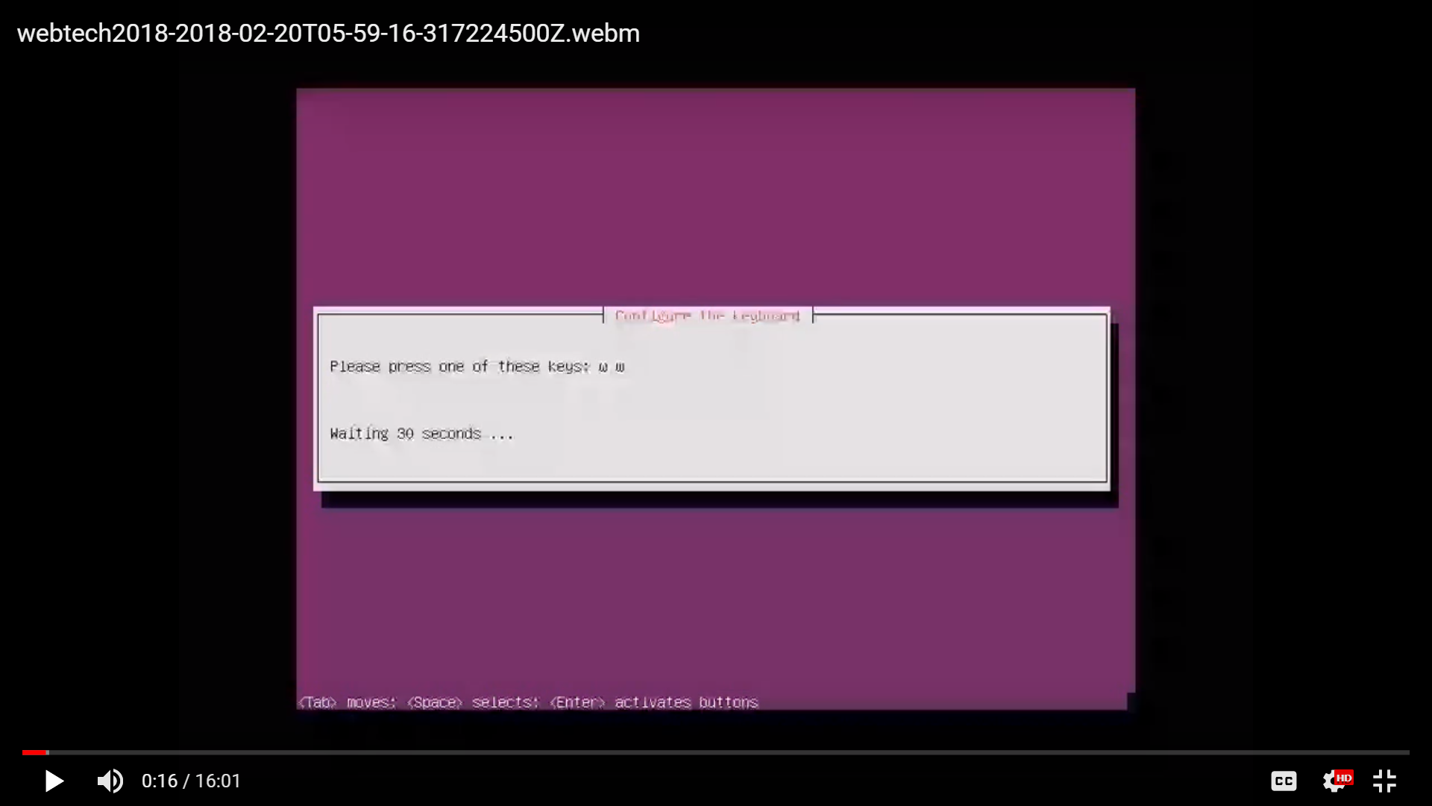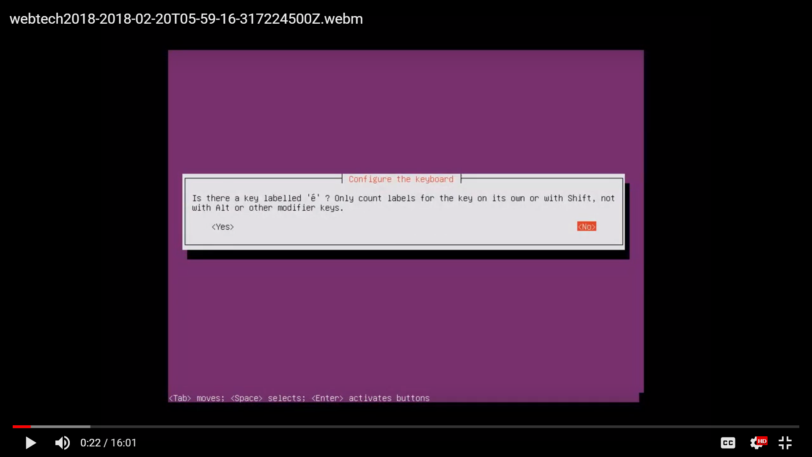

Image 3.7 Image 3.8

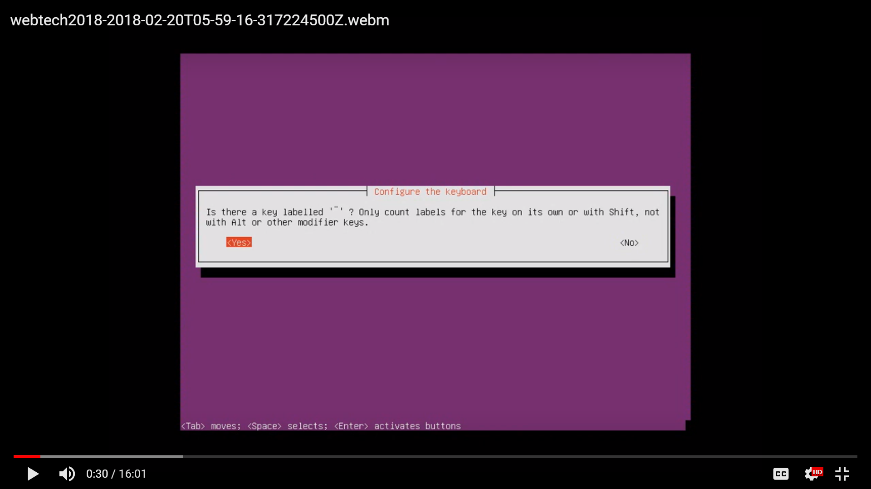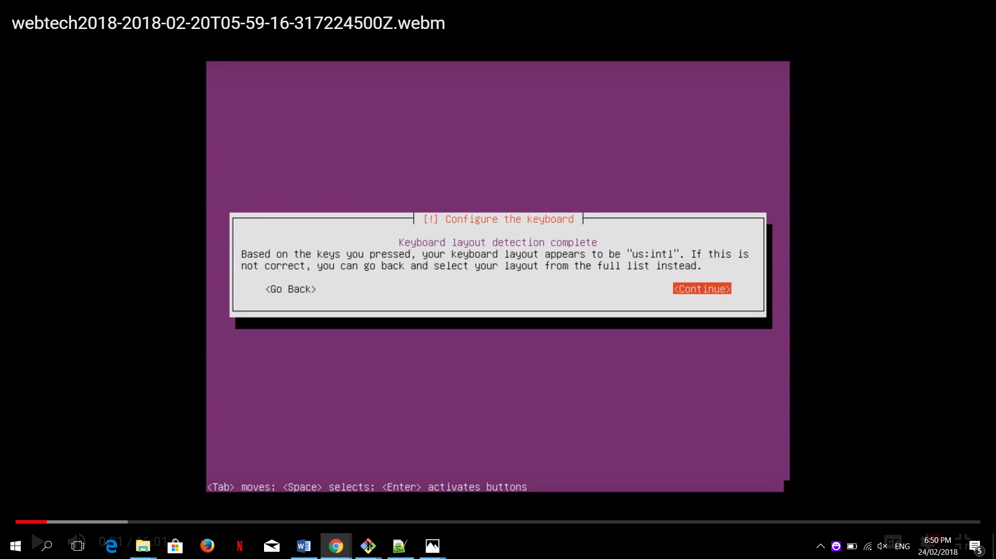

Image 3:9 Image 3:10

* Wait to response.

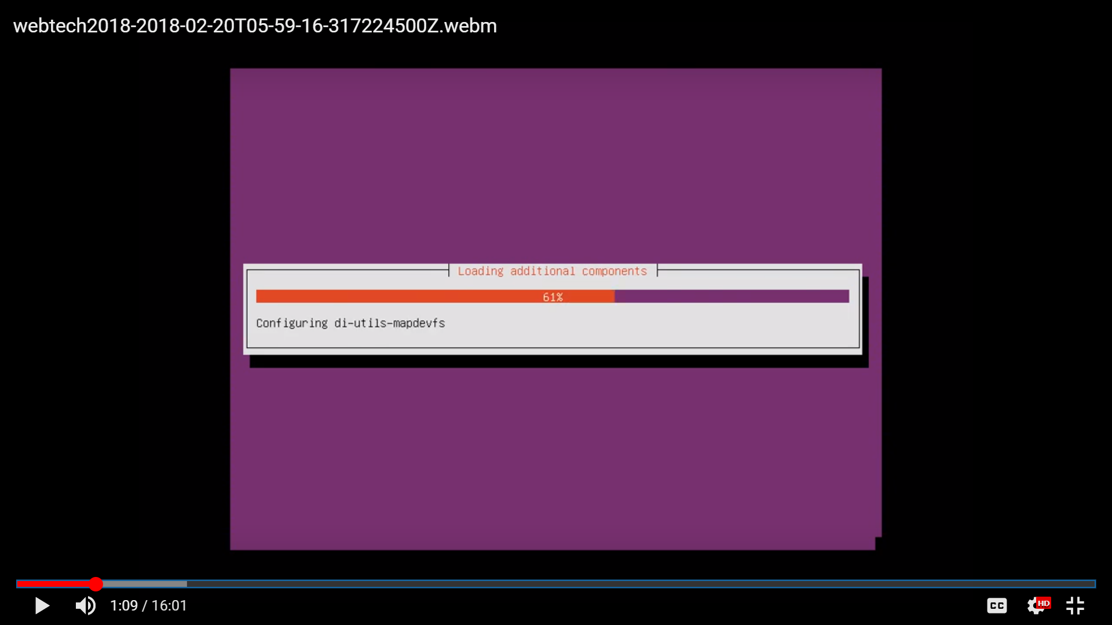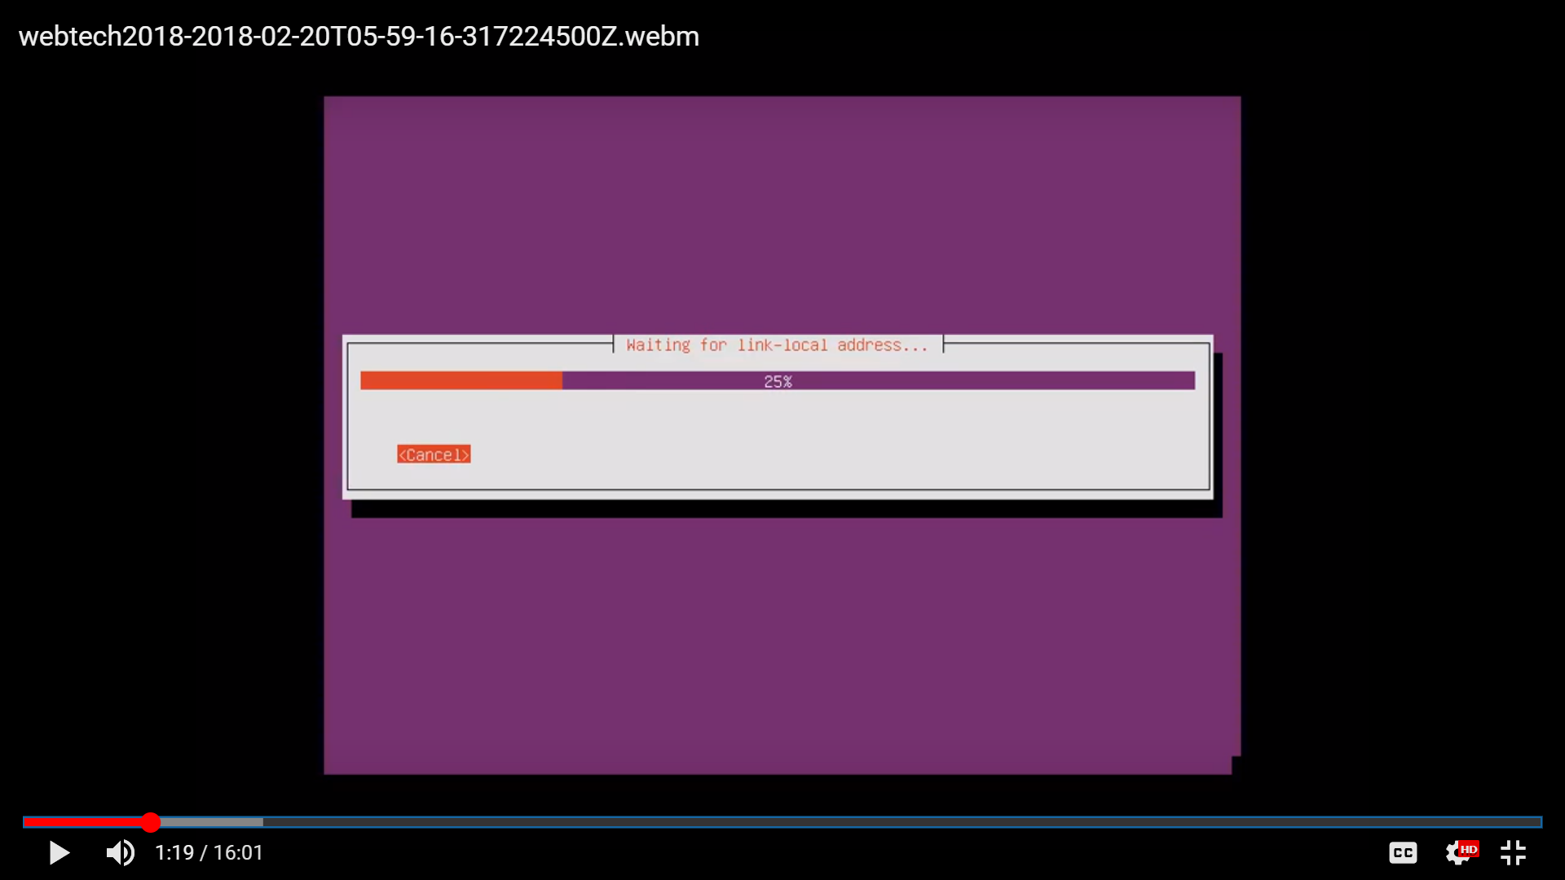

Image 3.11 Image 3.12

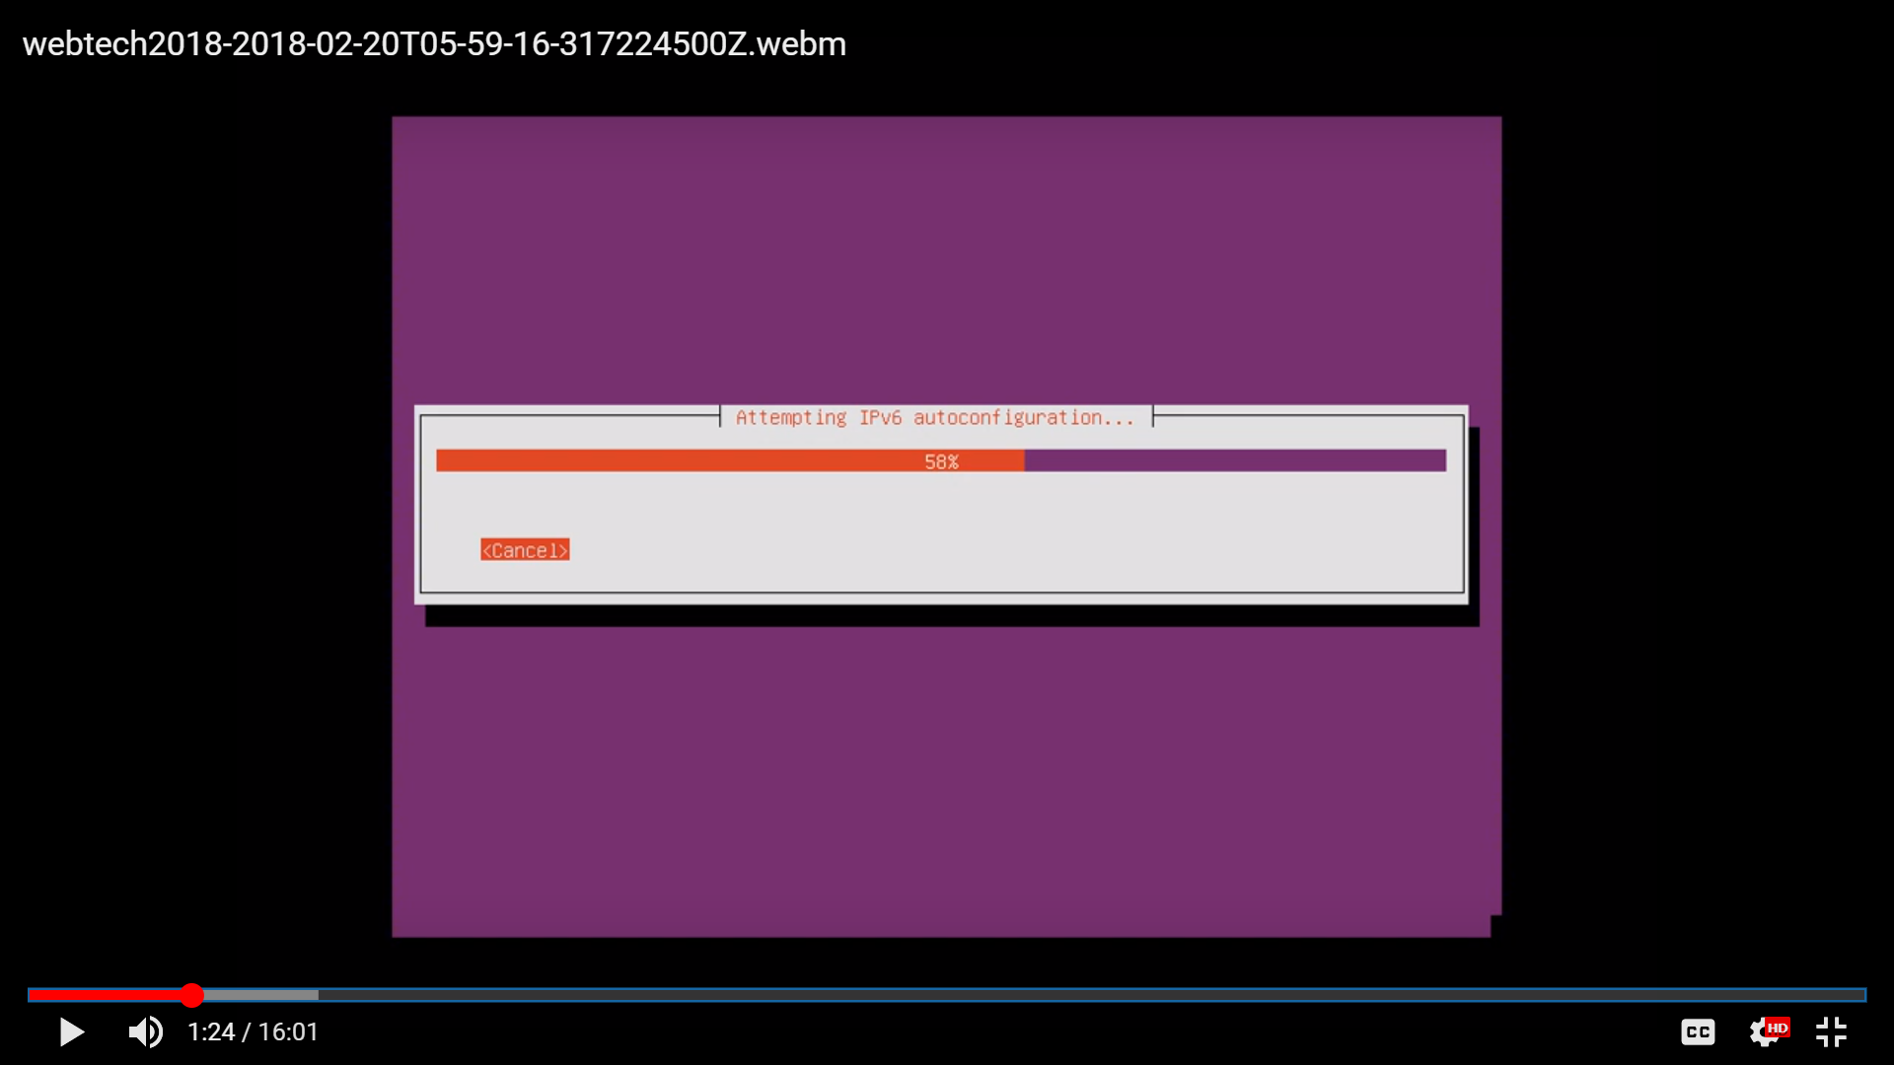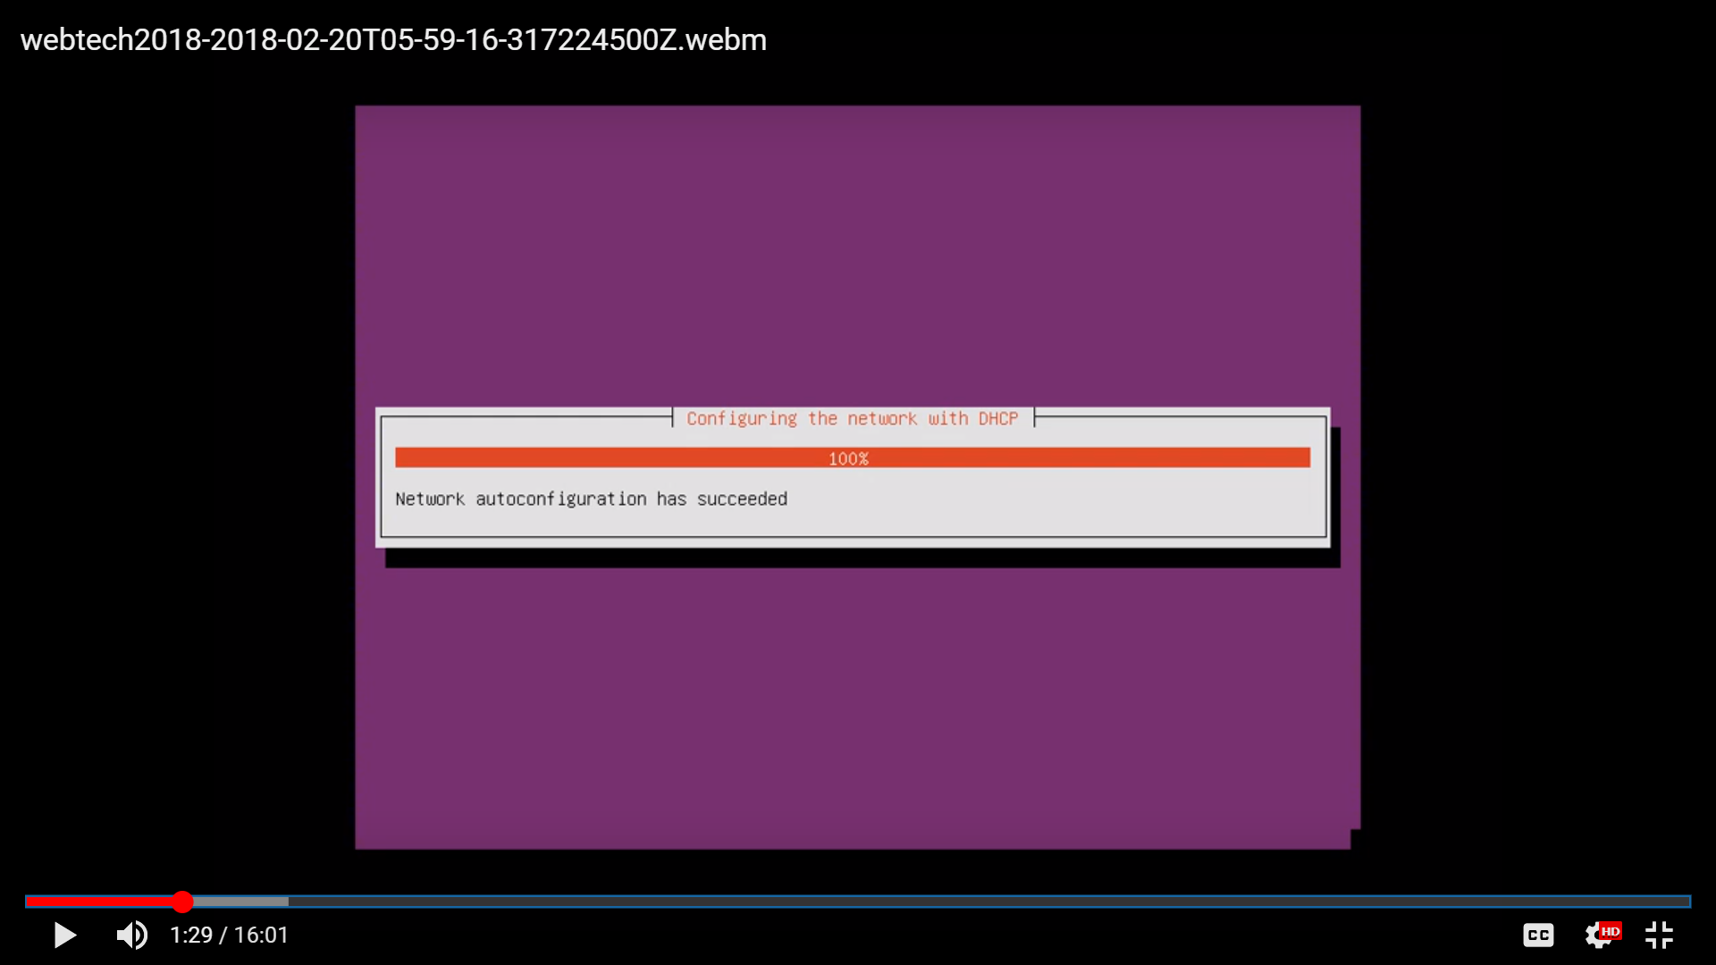

Image 3.13 Image 3.14

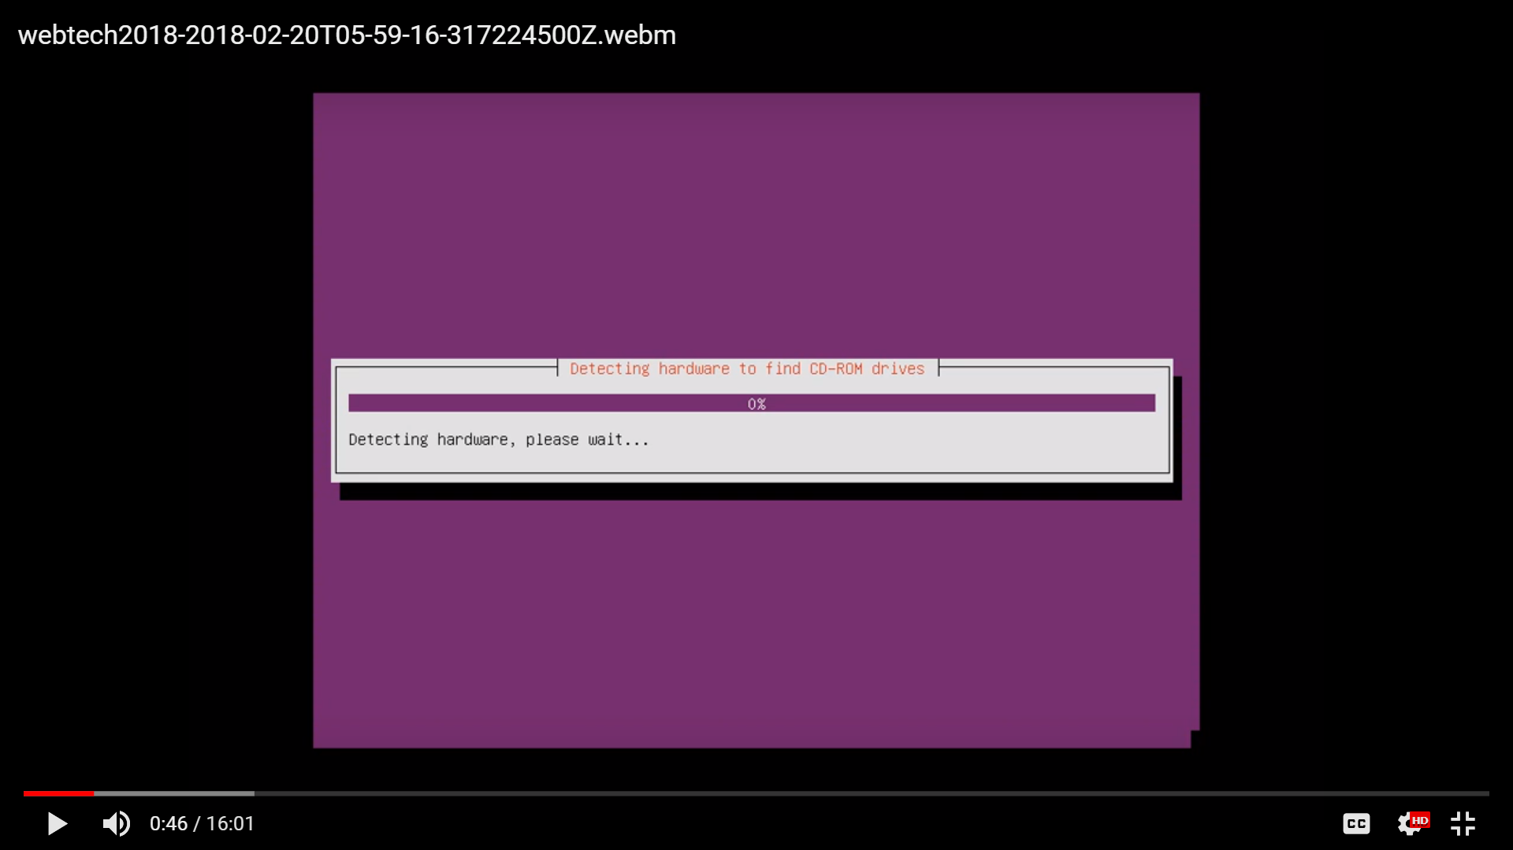

Image 3.15

* Setting up name of the user.

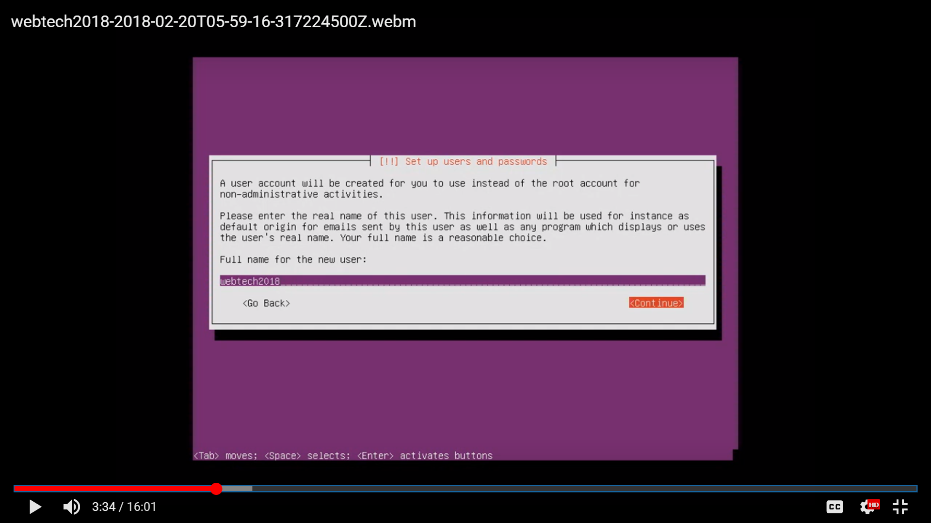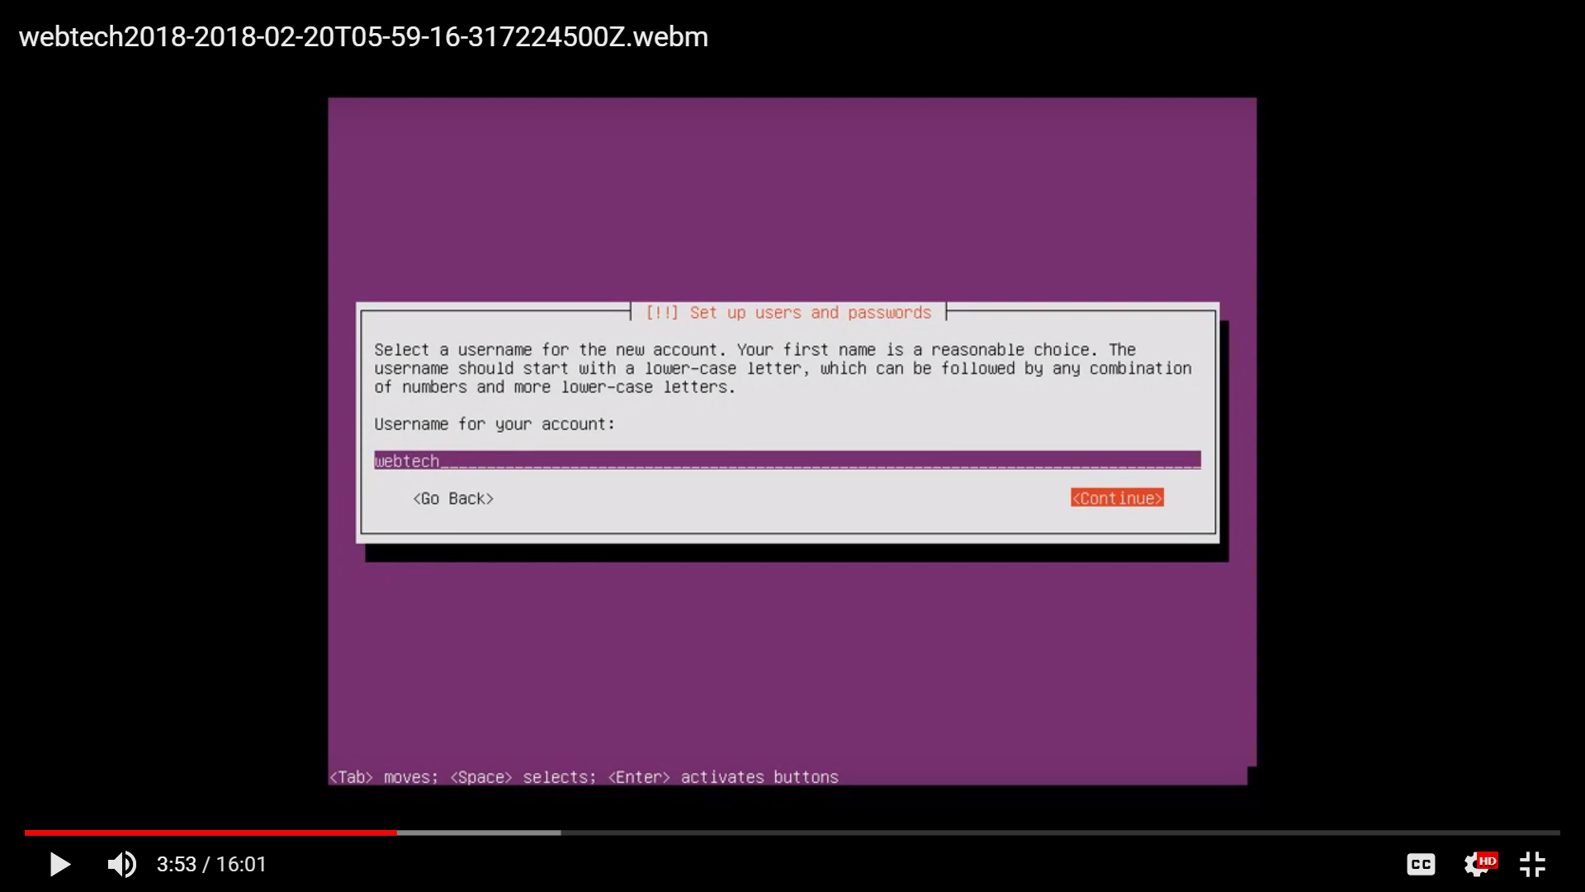

Image 3.16 Image 3.17

* Setting up password for the user.
* Choose “yes” if it is ok to have weak password and “no” for otherwise.
* Chose “no” for the encrypt the home directory.

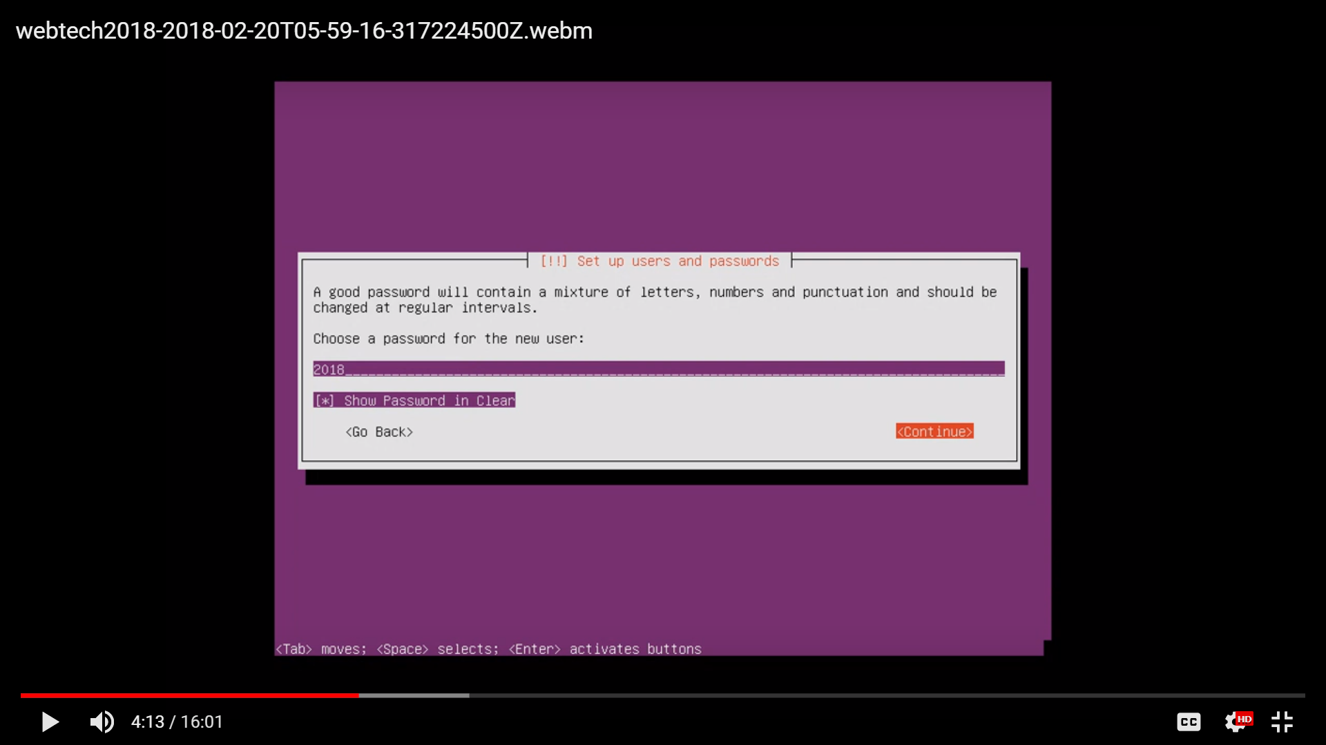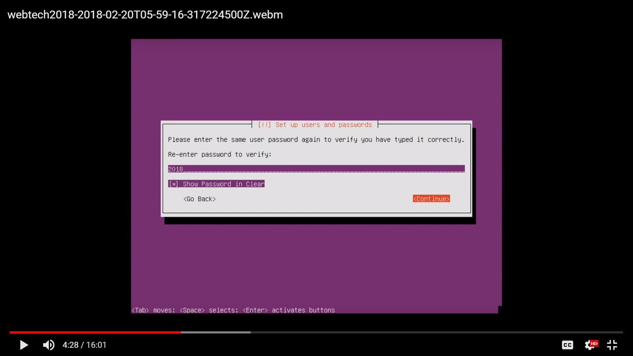 Image 3.18 Image 3.19

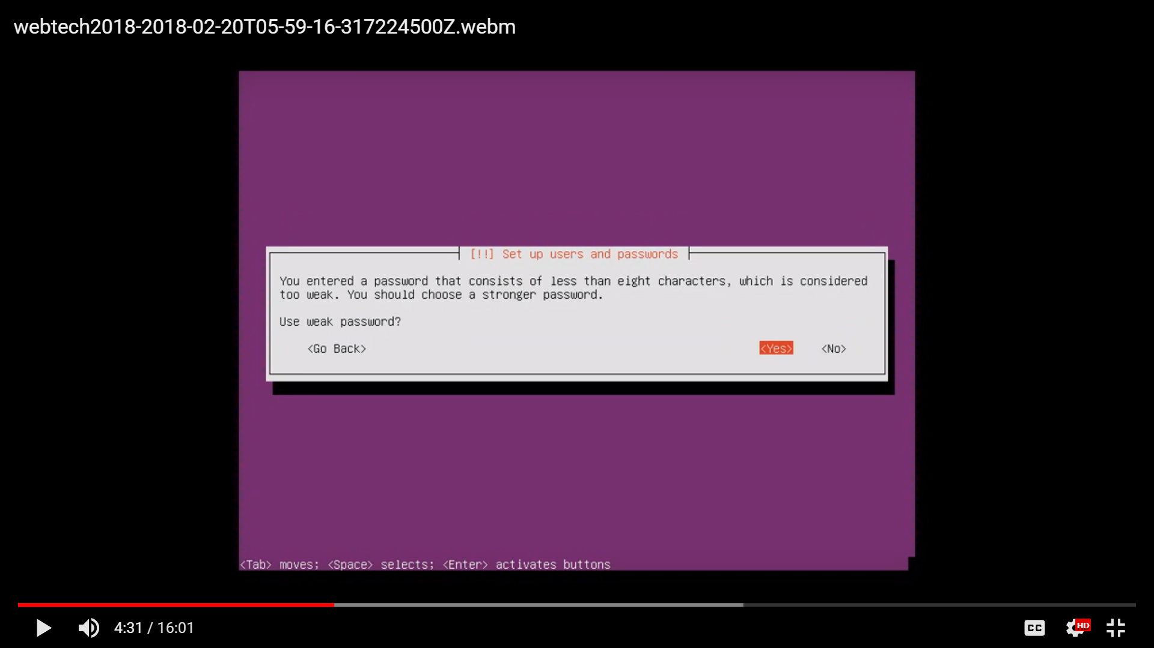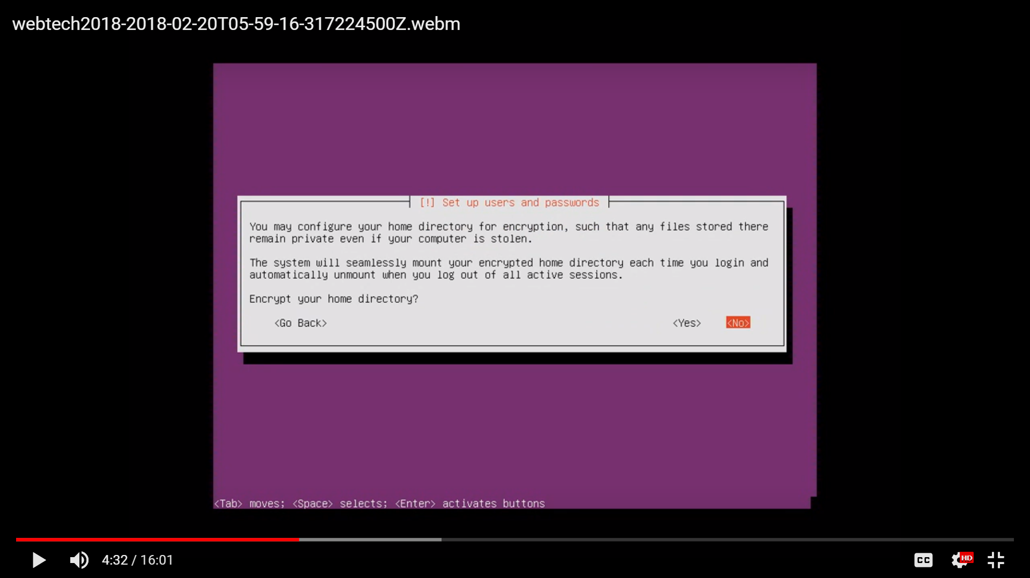

Image 3.20 Image 3.21

* Choose “yes” if the time zone is correct and “no” for otherwise.

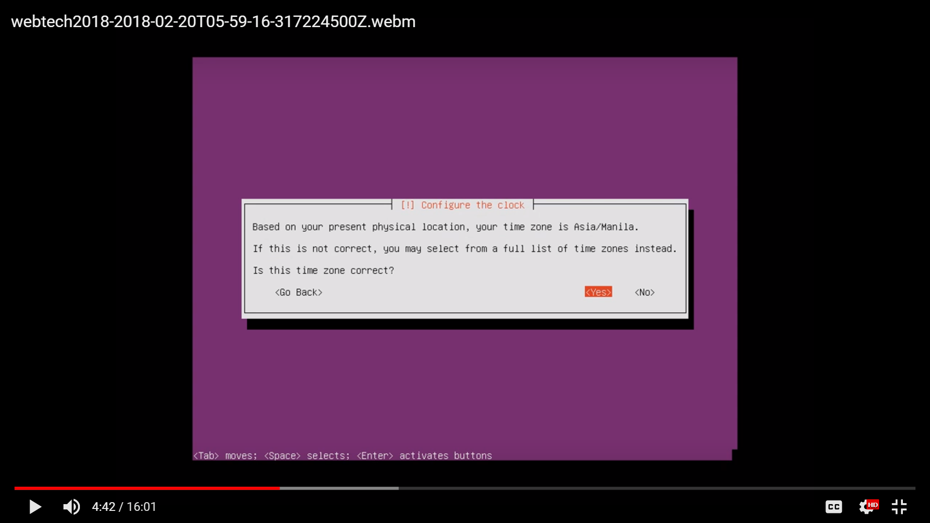

Image 3.22

* Wait to response.

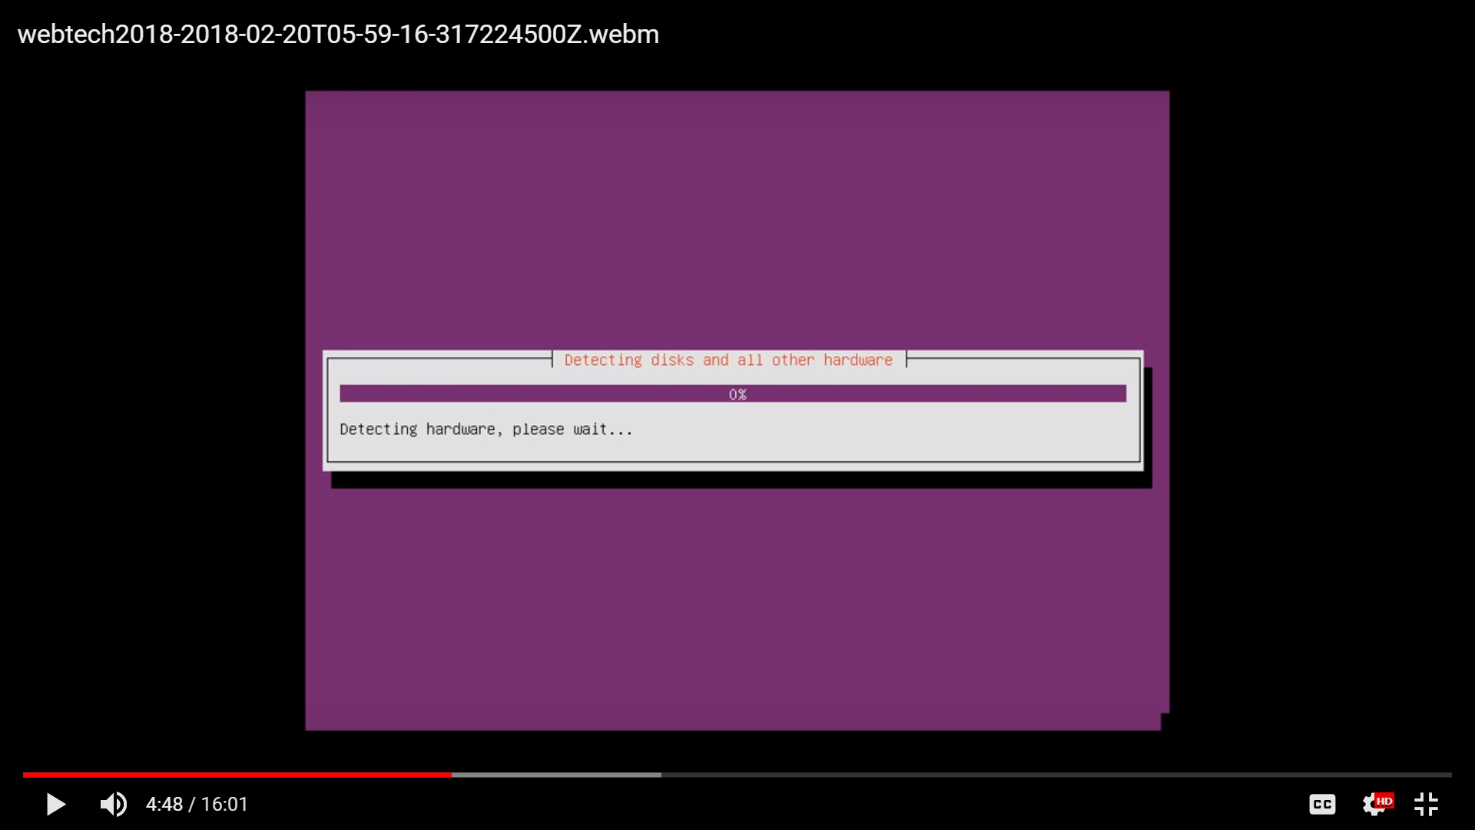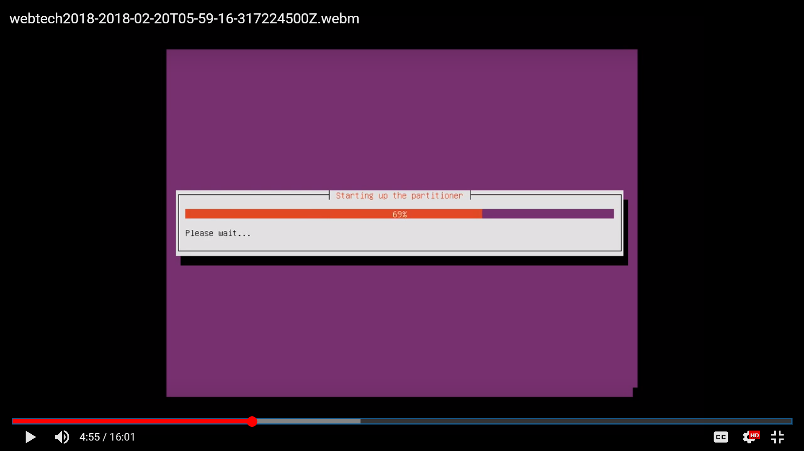

Image 3.23 Image 3.24

* Setting up disk.
* Choose “guided - use entire disk and set up LVM”.
* Choose “yes” to change disks and configure LVM.
* Choose a proper amount of volume for guided partitioning.
* Allow changes to the disks.

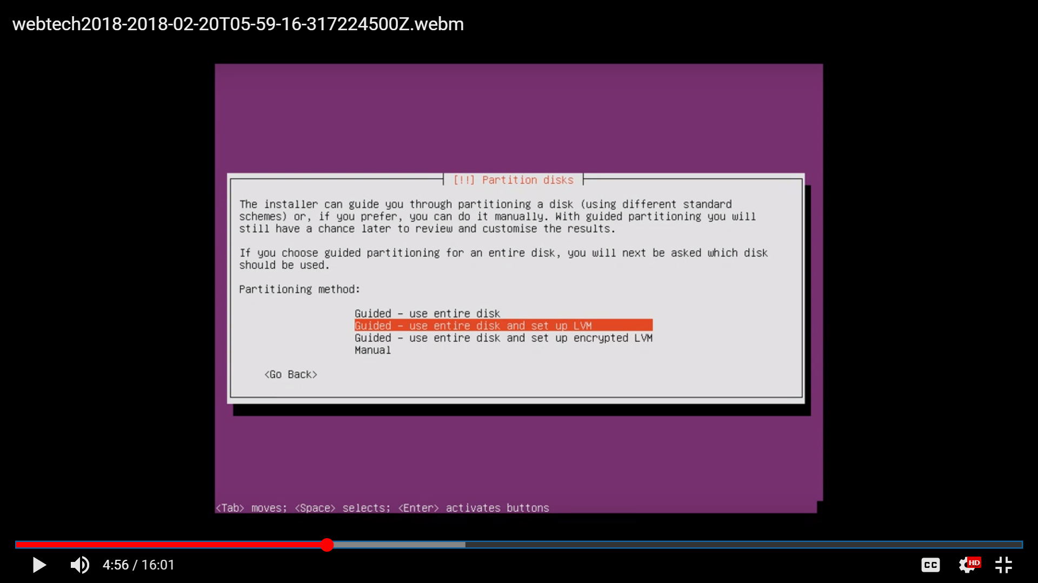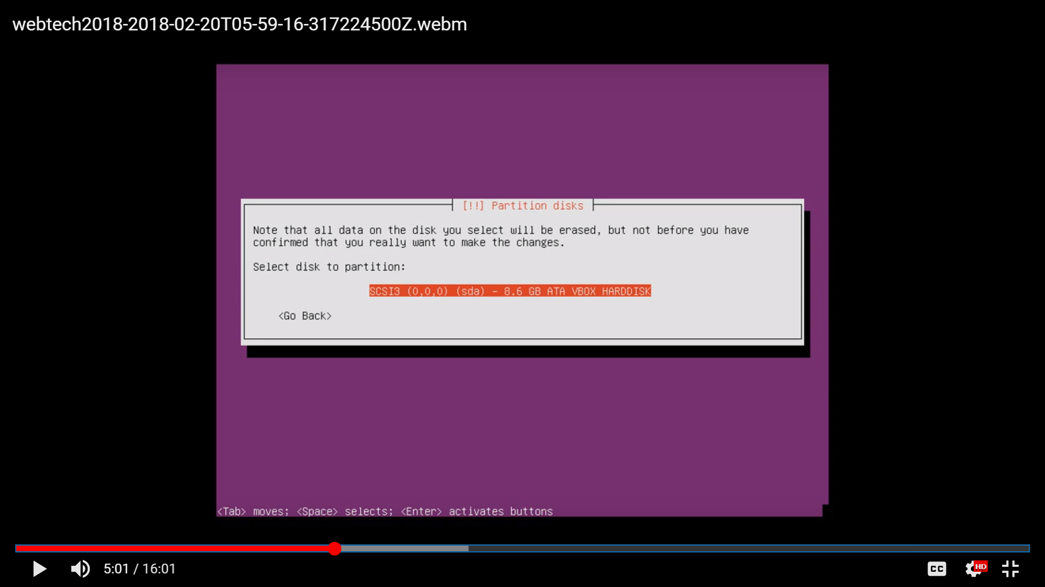

Image 3.25 Image 3.26

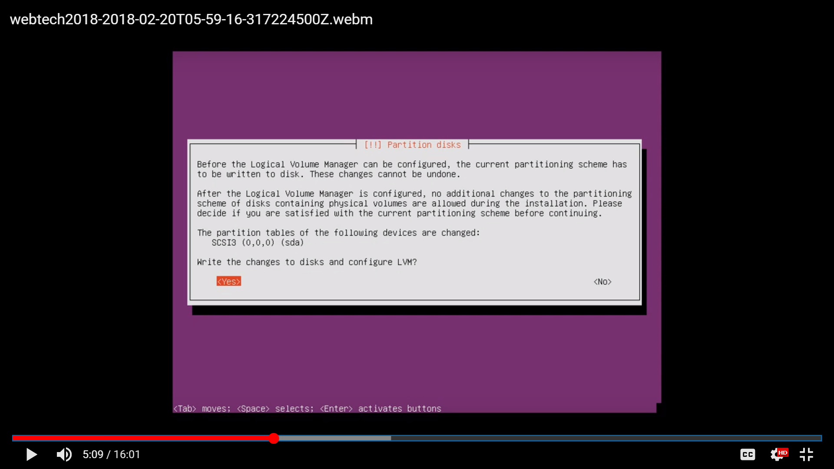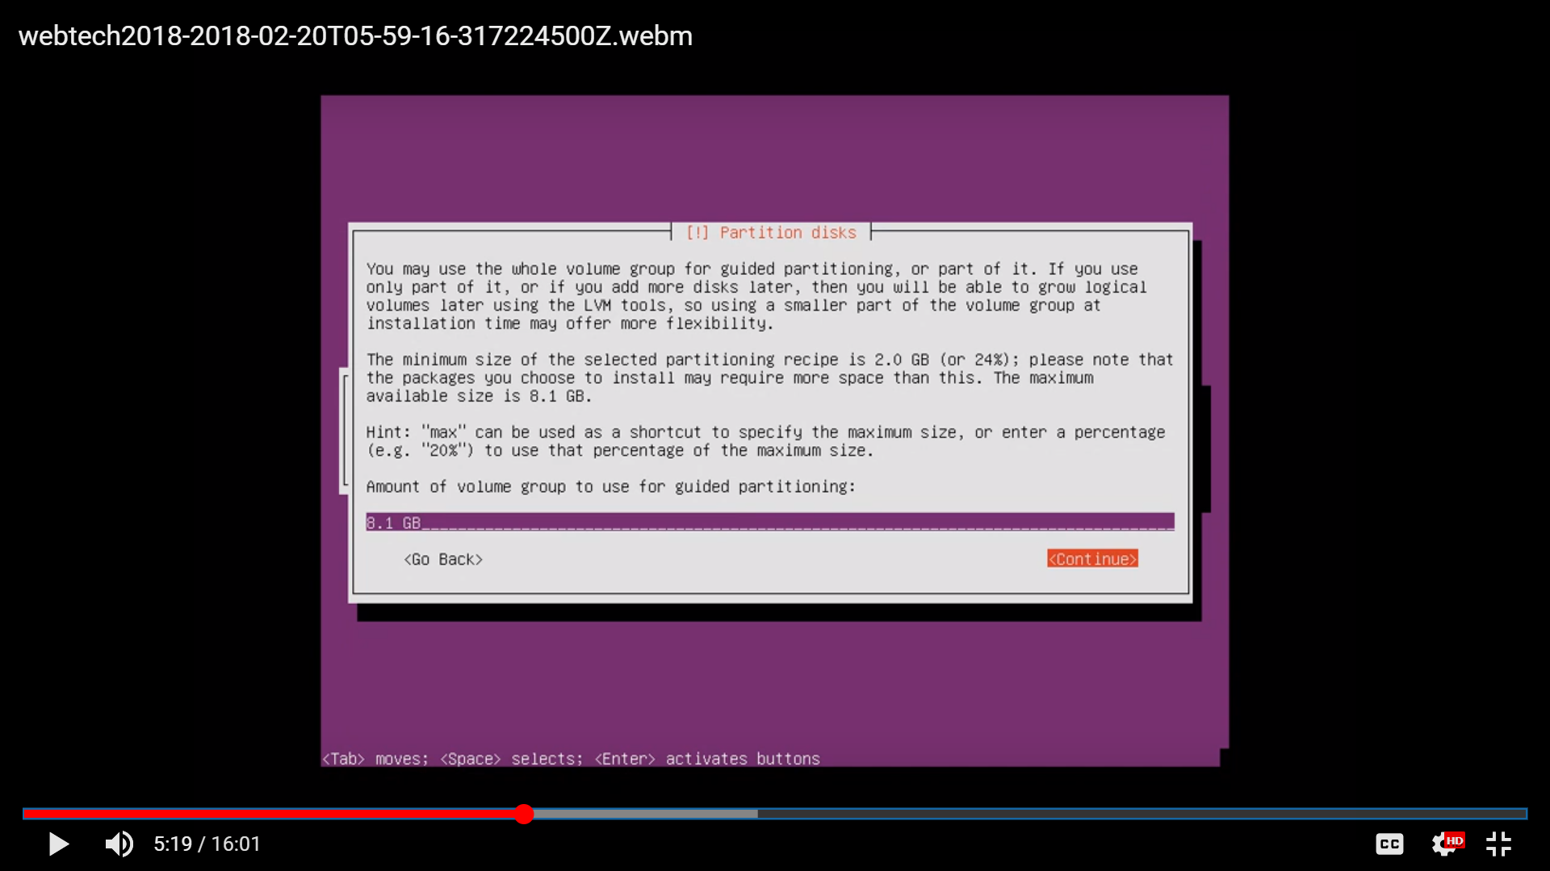

Image 3.27 Image 3.28

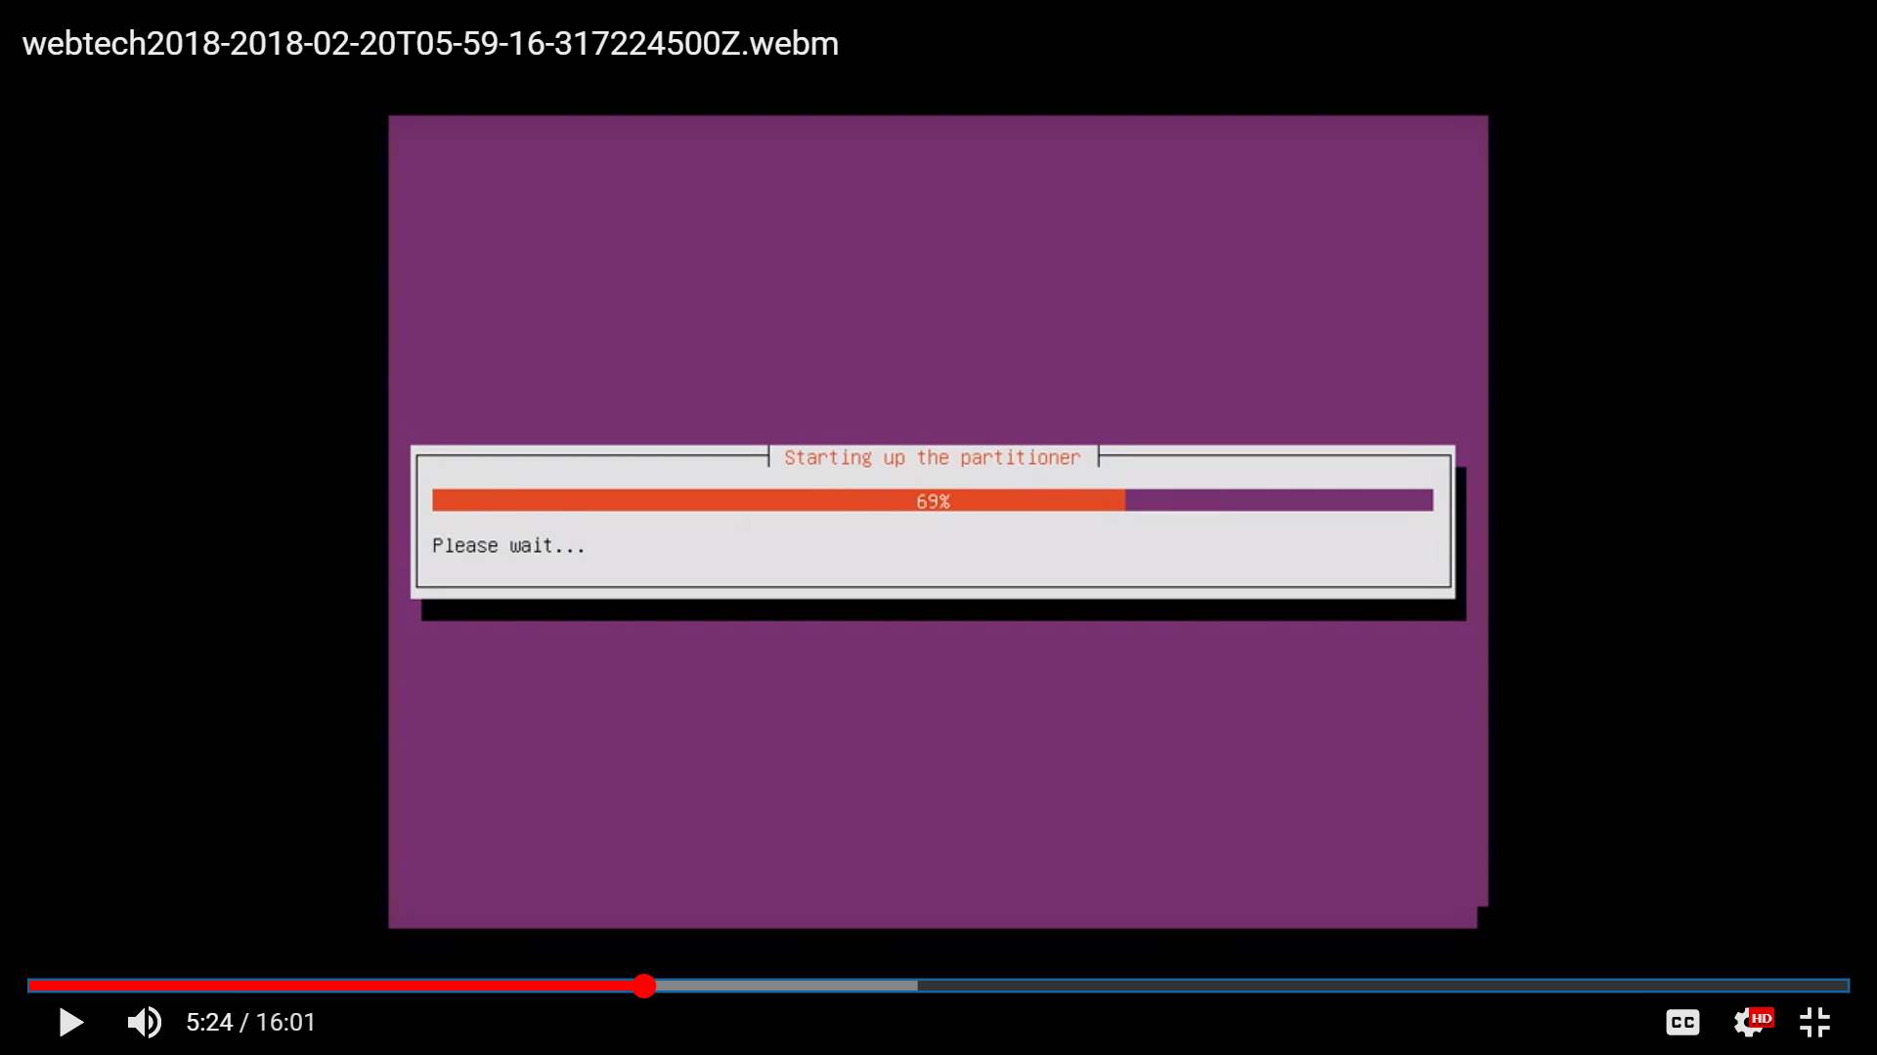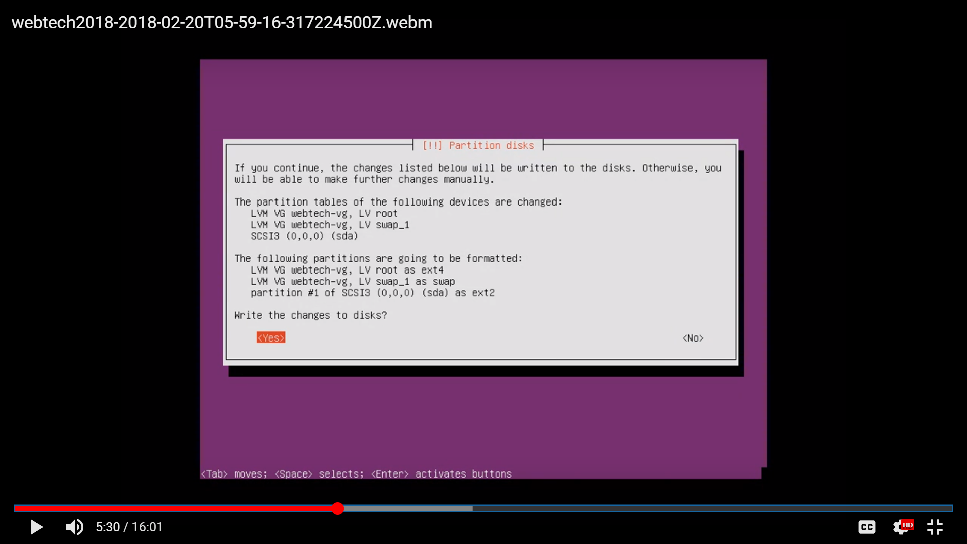

Image 3.29 Image 3.30

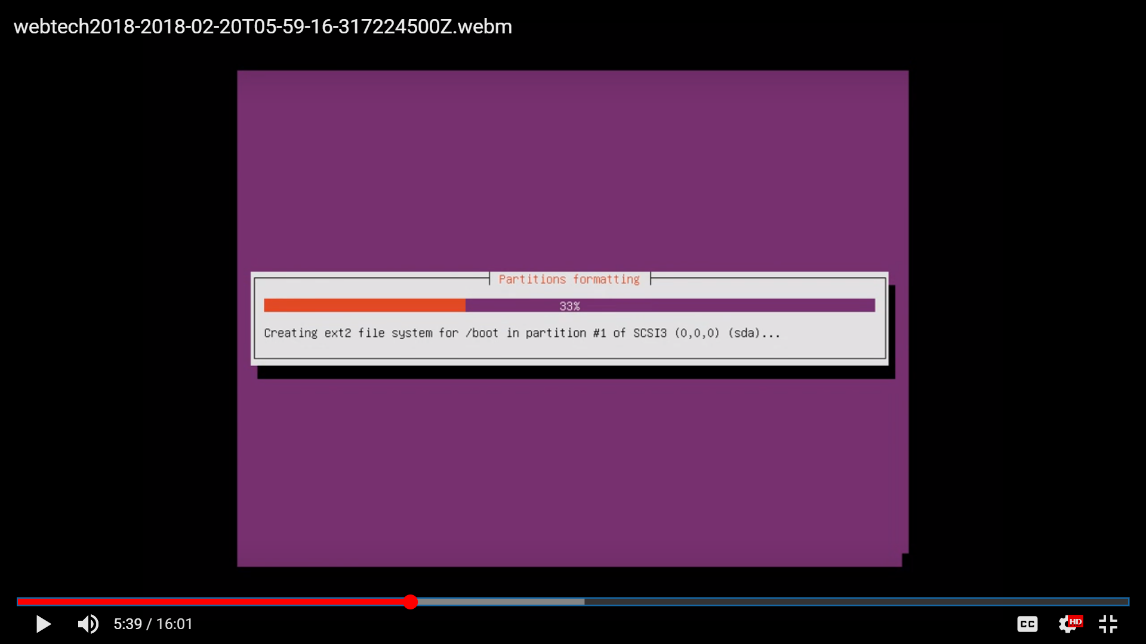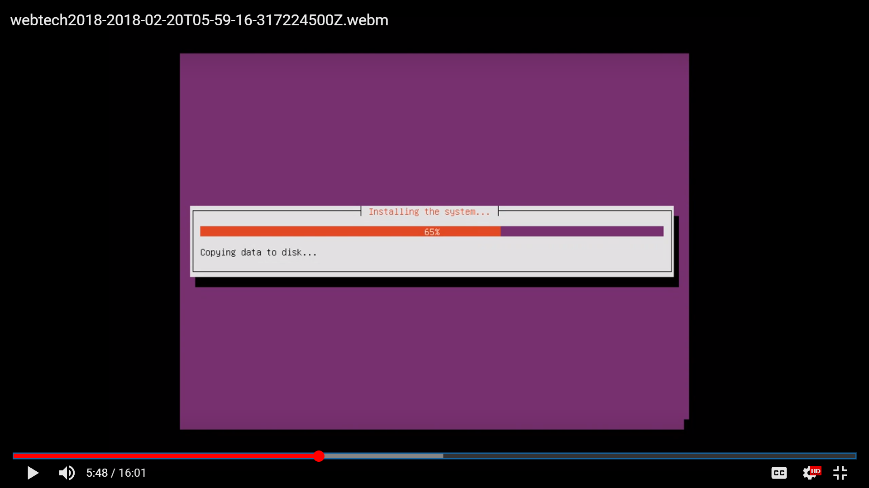

Image 3.31 Image 3.32

* Configuring.
* Leave the HTTP proxy blank.

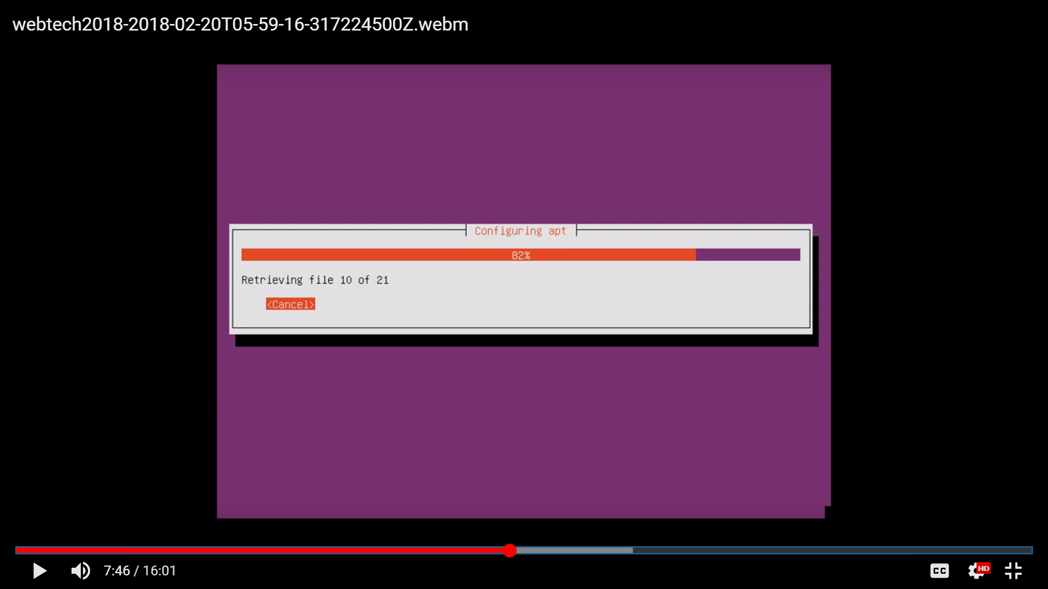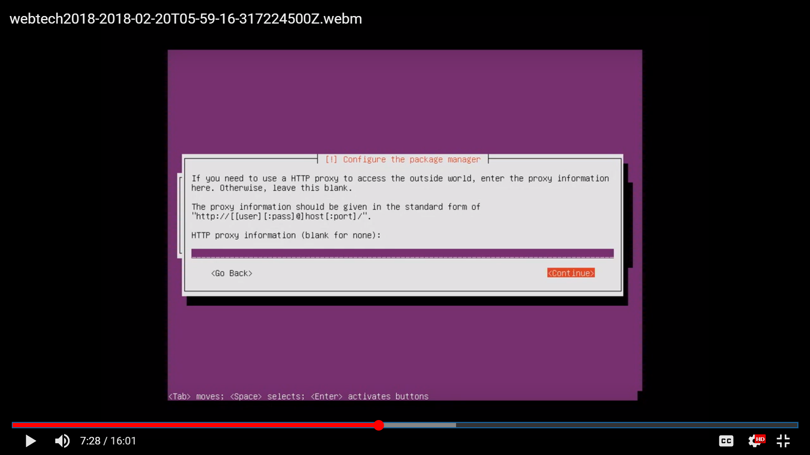

Image 3.33 Image 3.34

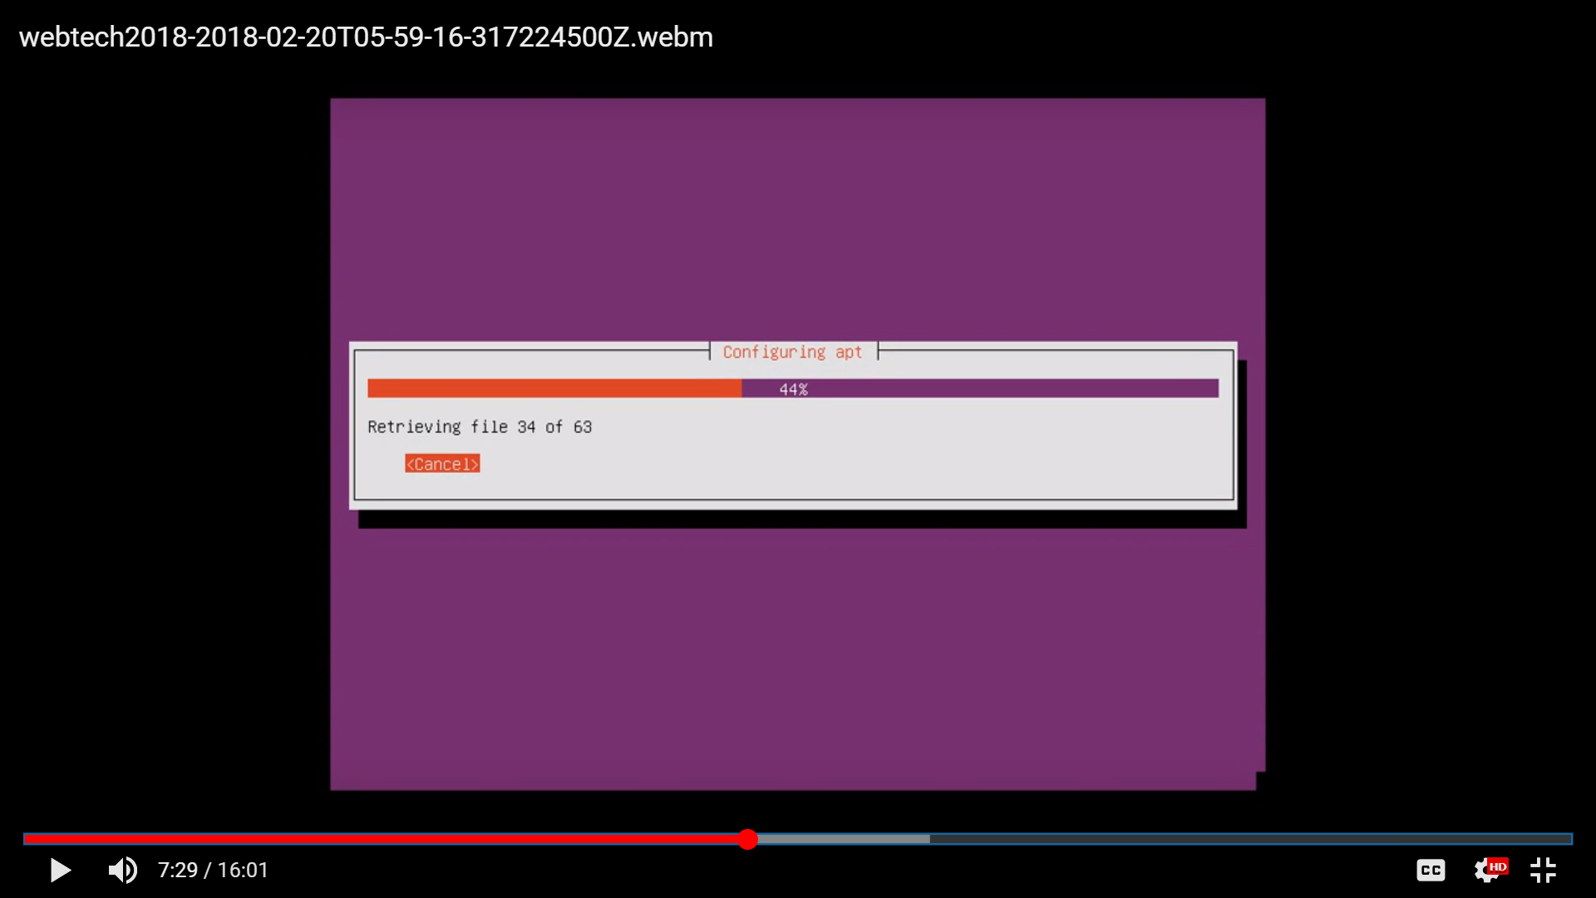

Image 3.35

* Installing of software.
* Choose “No automatic updates”
* Choose “standard system utilities” and “OpenSSH Server”

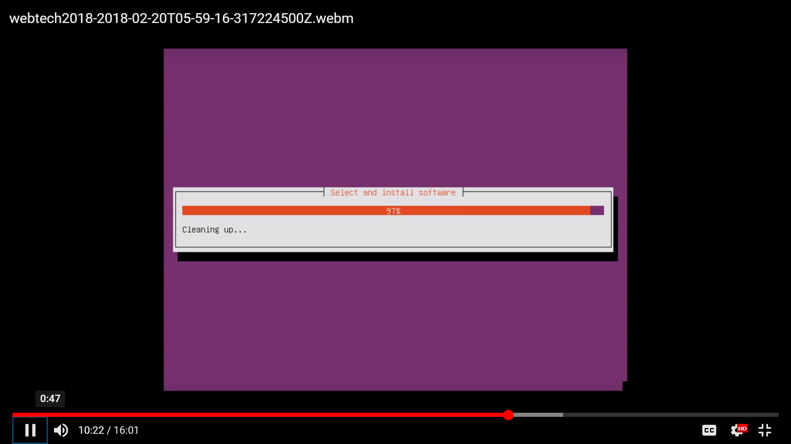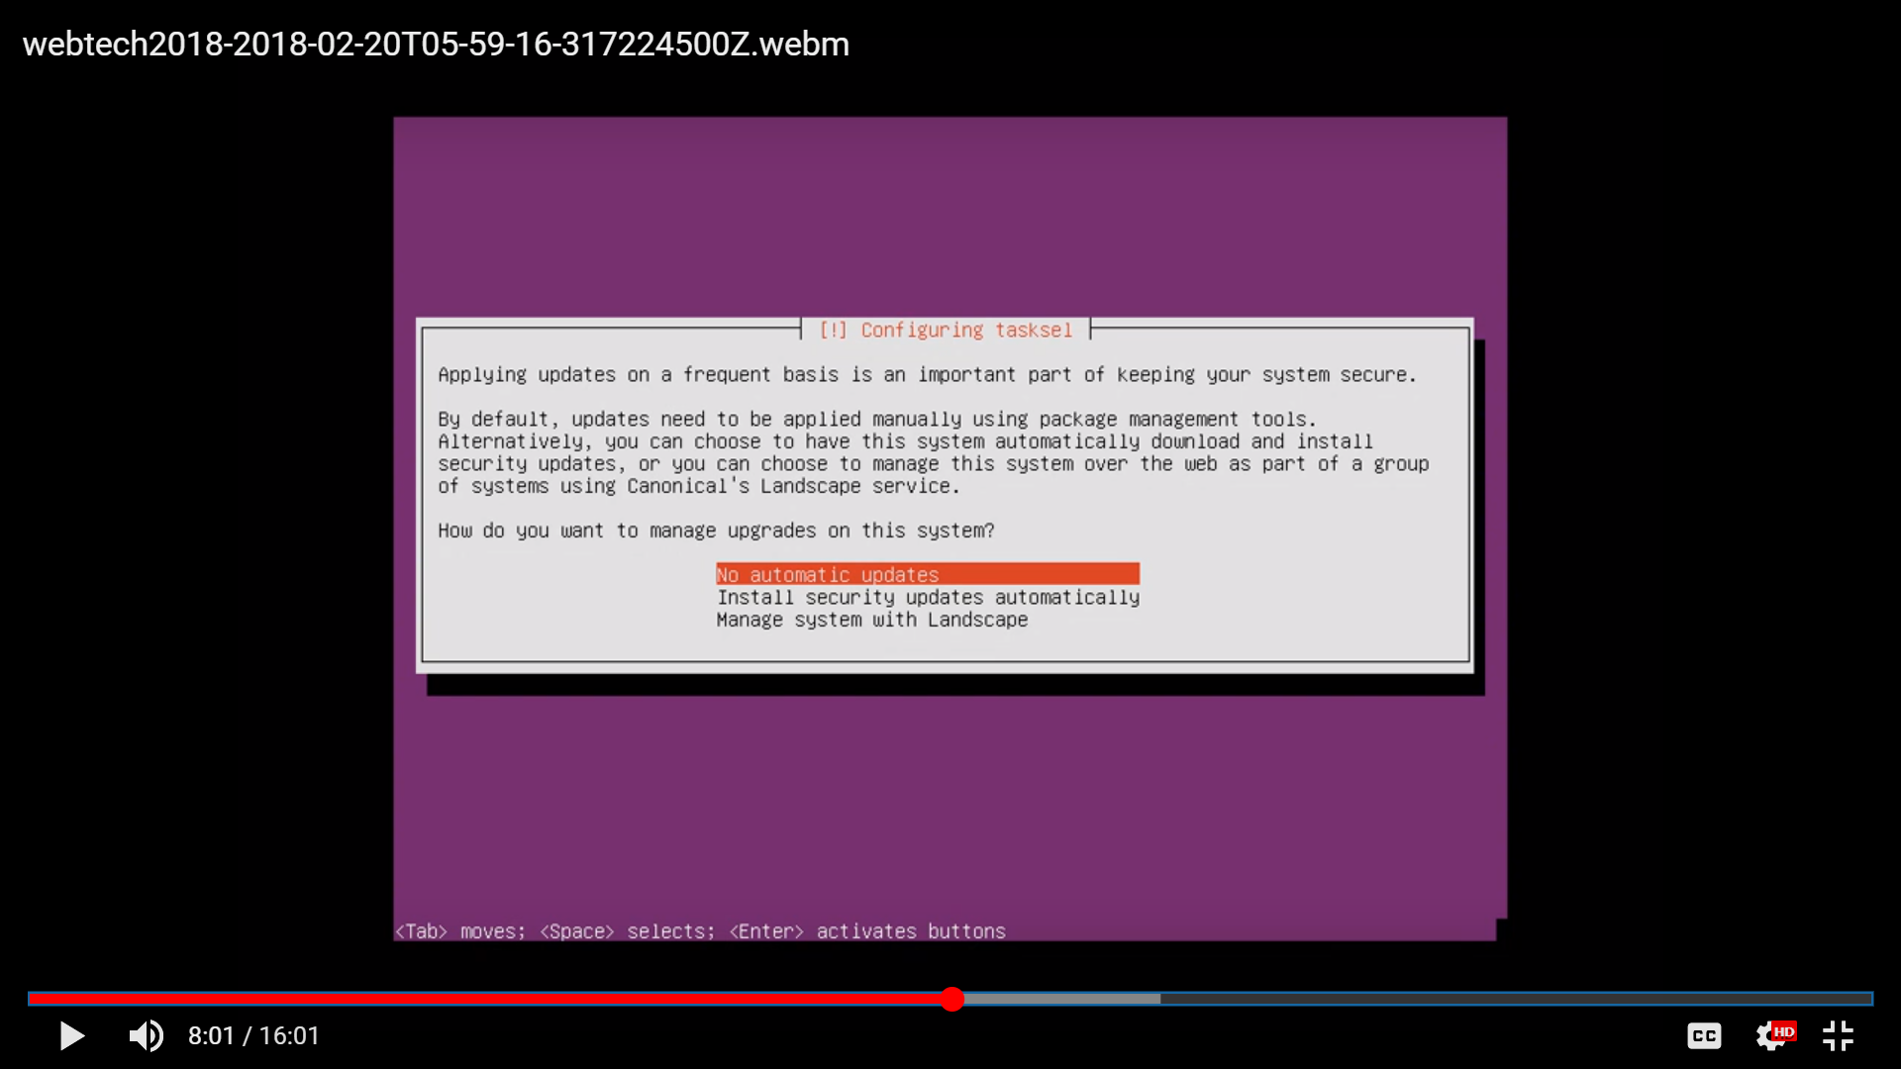

Image 3.36 Image 3.37

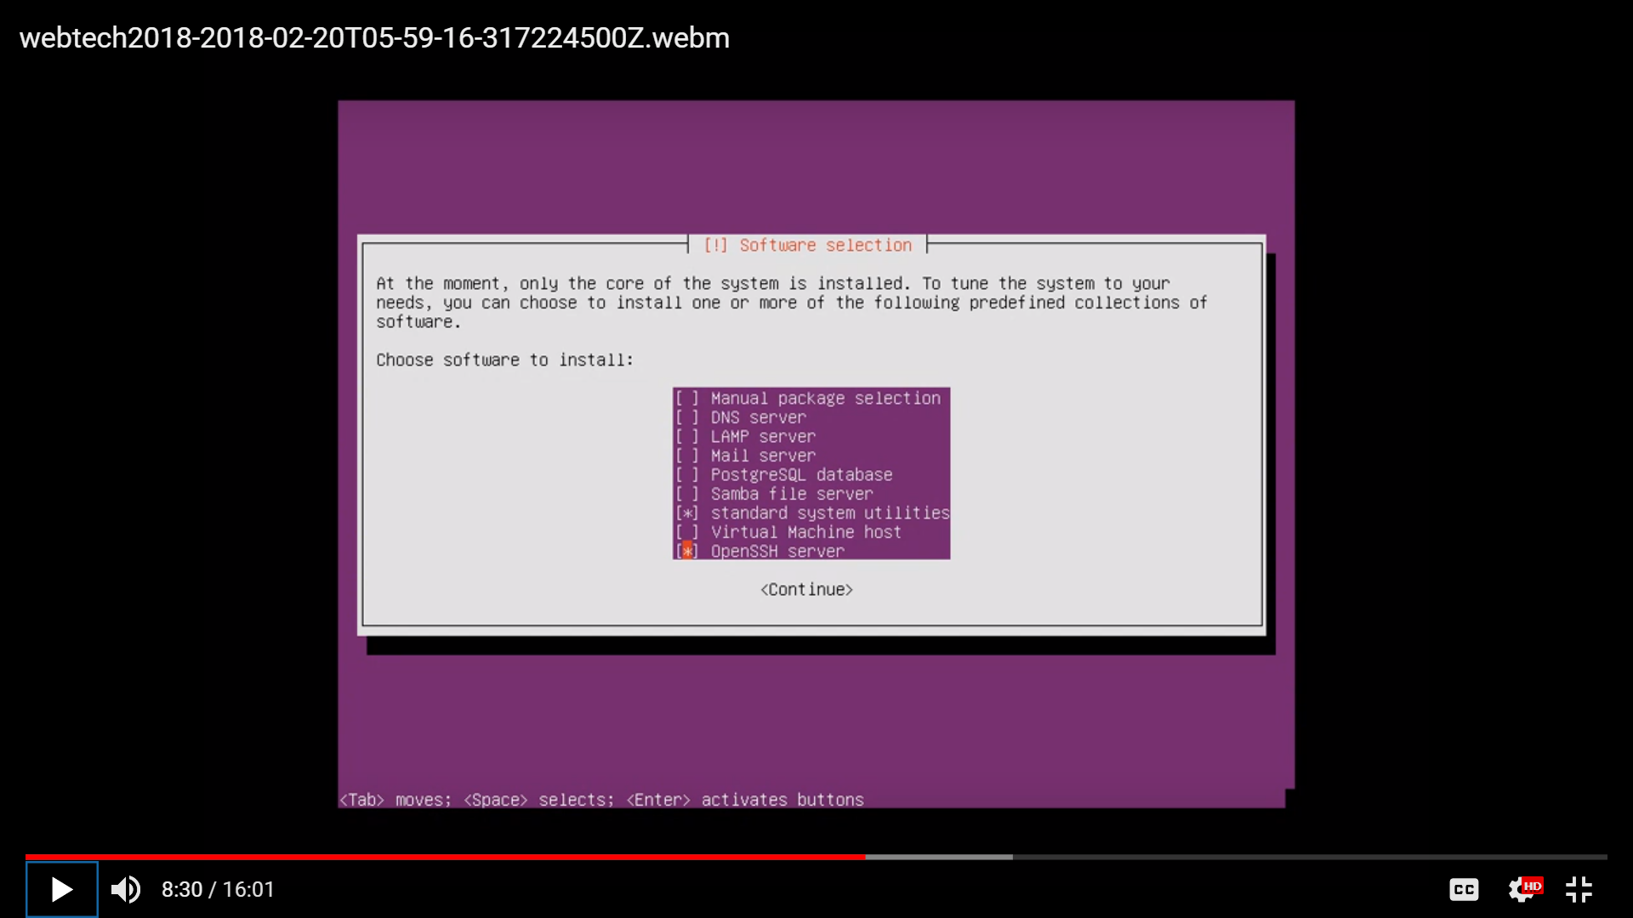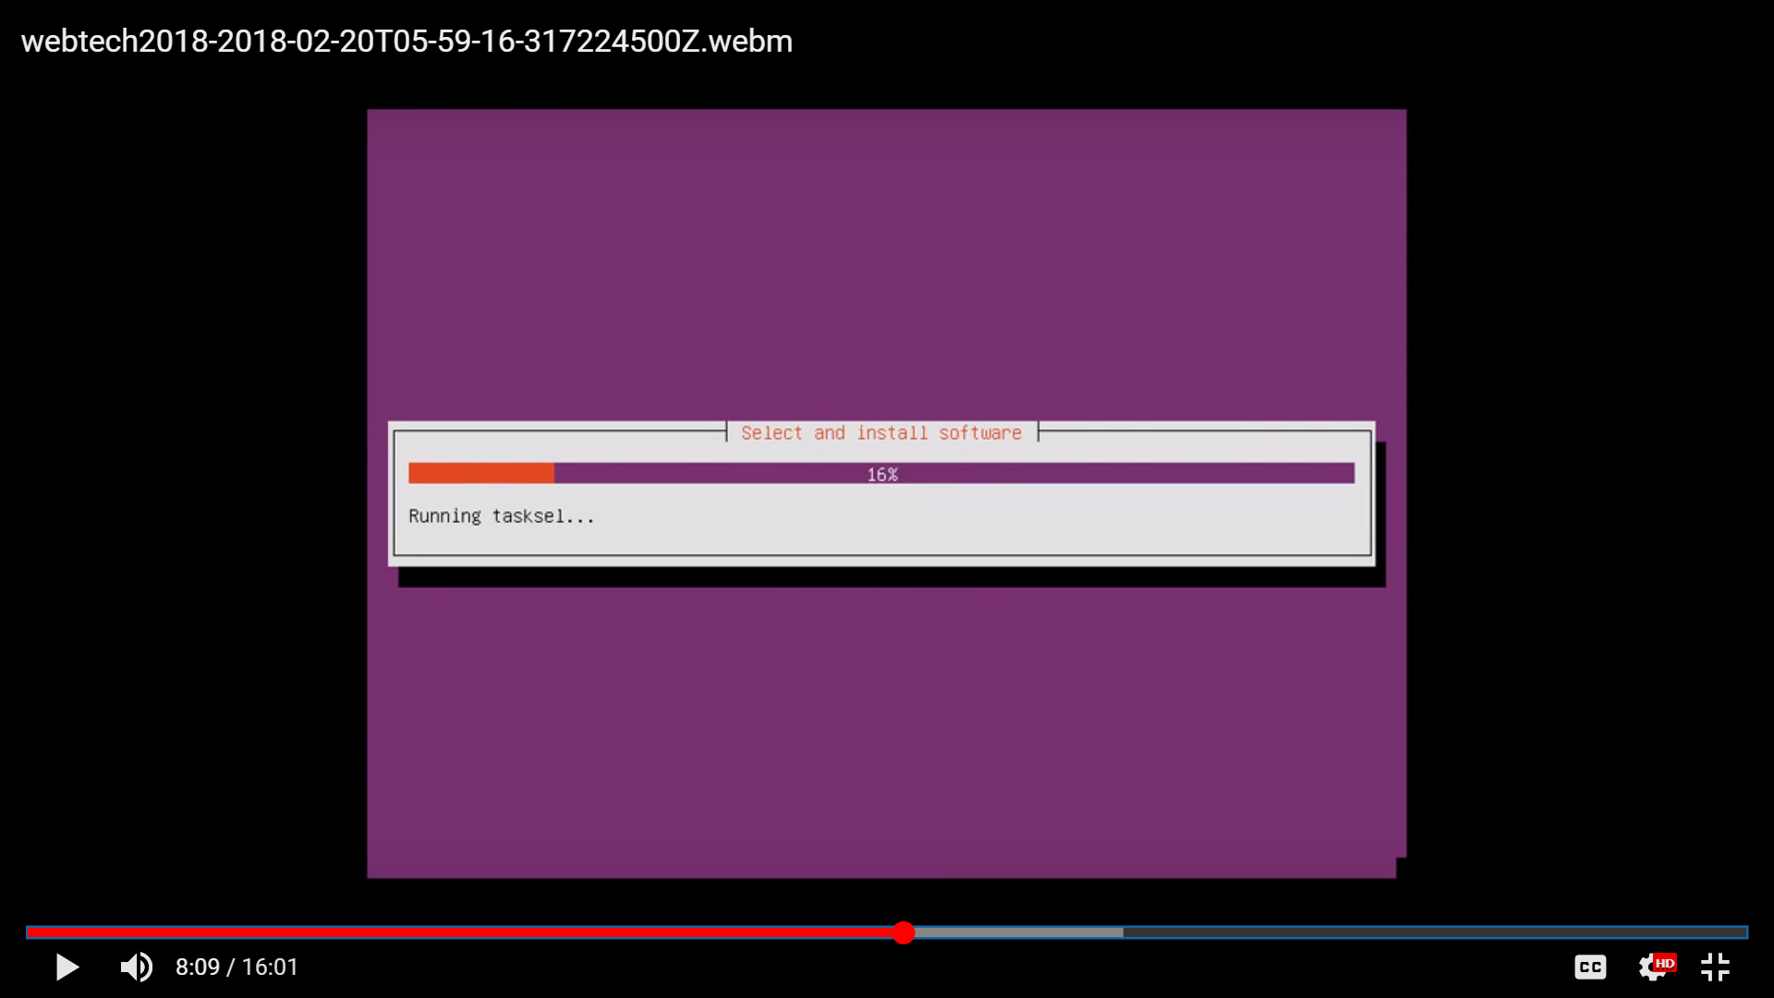

Image 3.38 Image 3.29

* Installing GRUB boot loader on hard hard disk.
* Choose “yes”

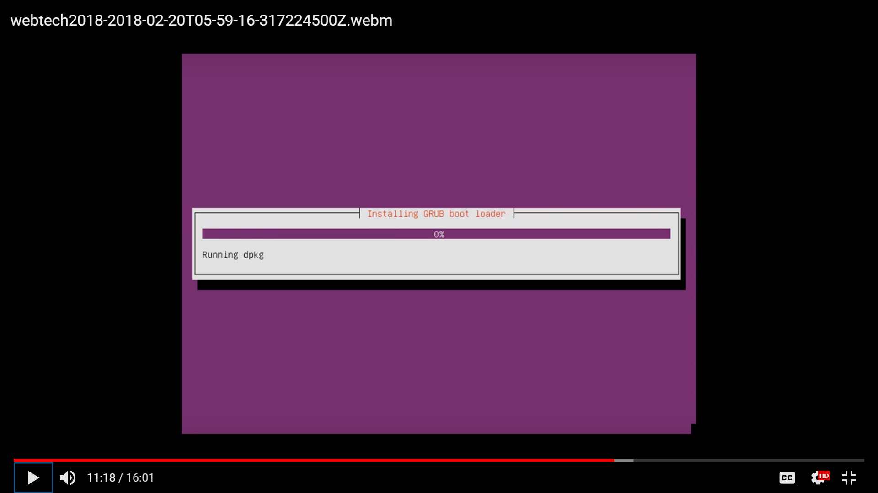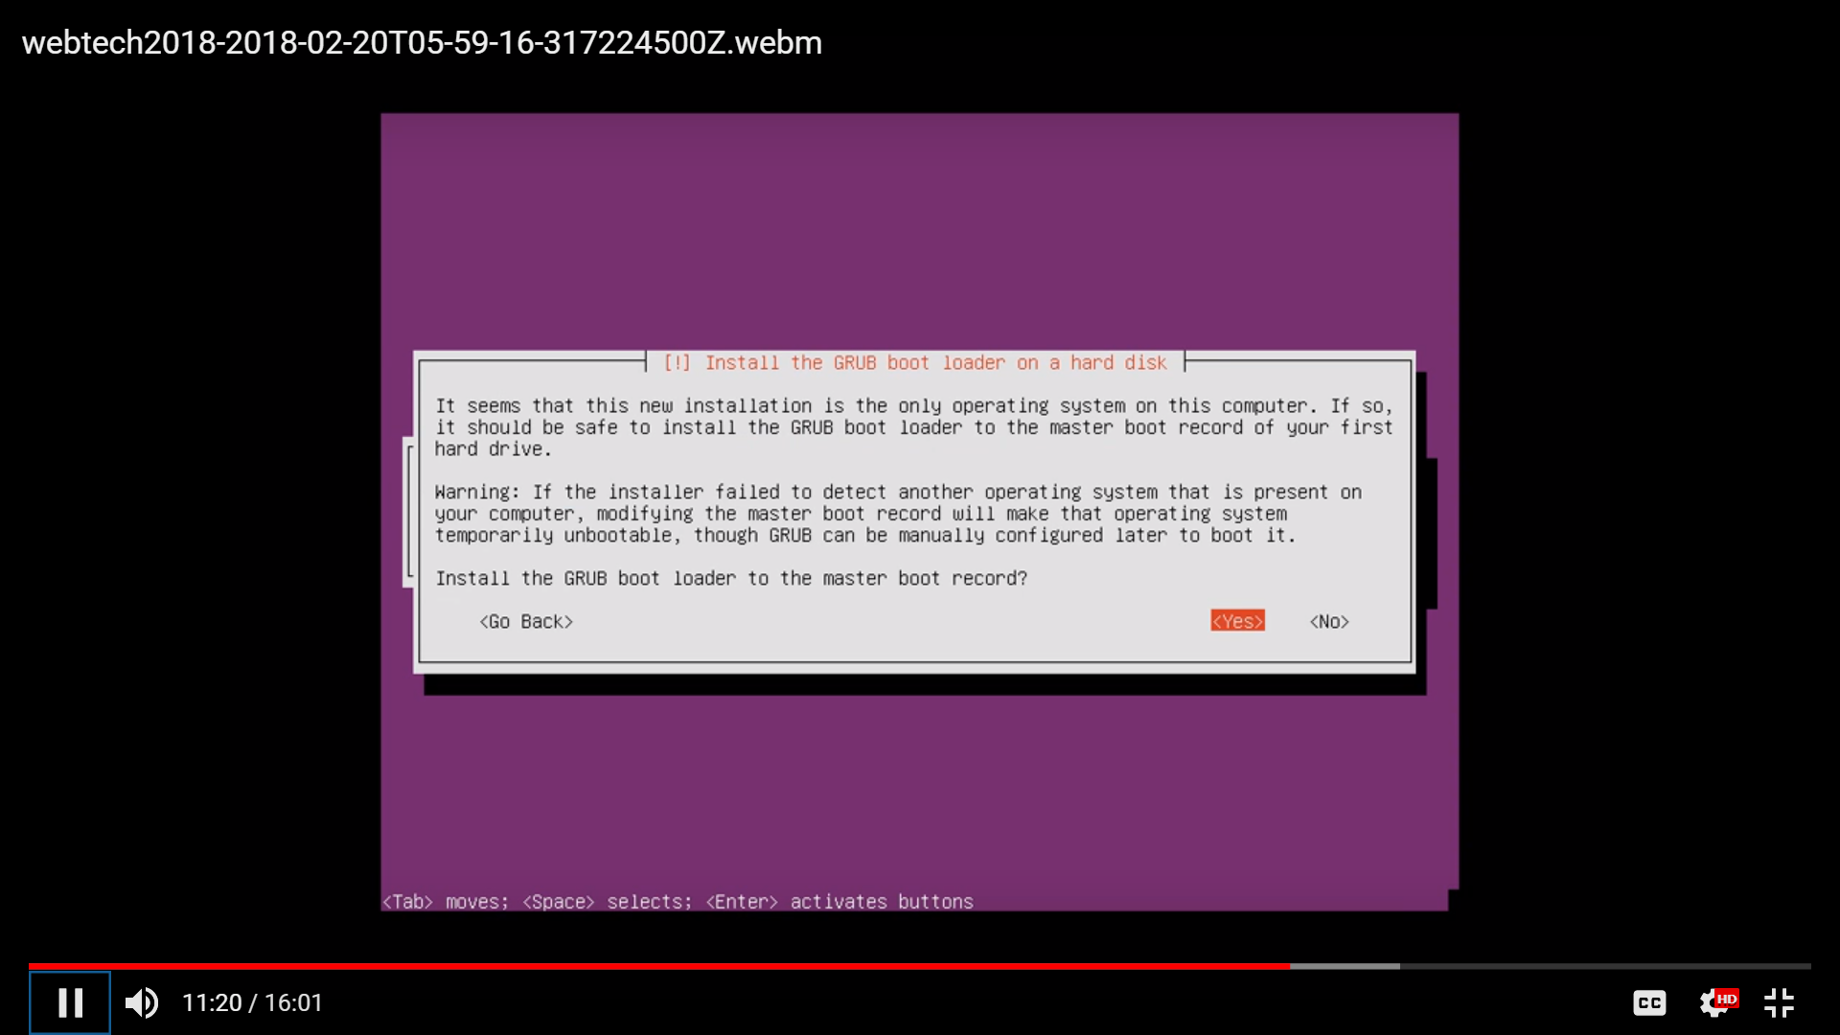

Image 3.40 Image 3.41

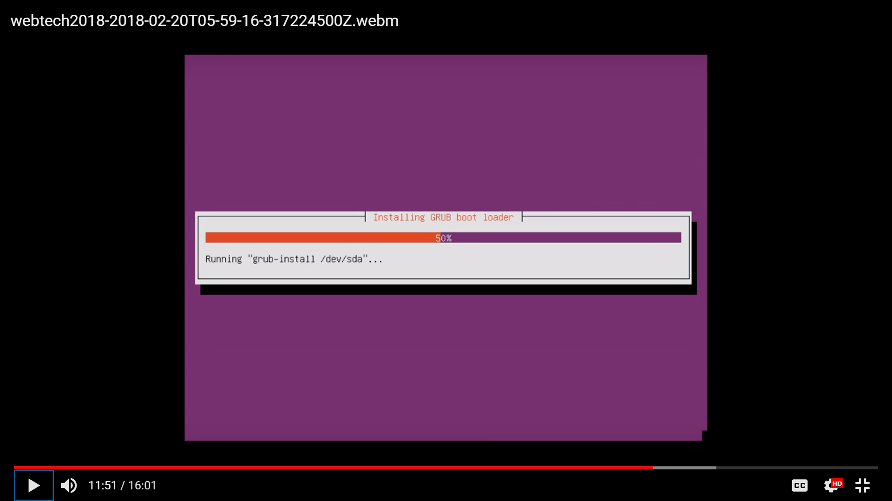

Image 3.42

* Allow booting into the system.

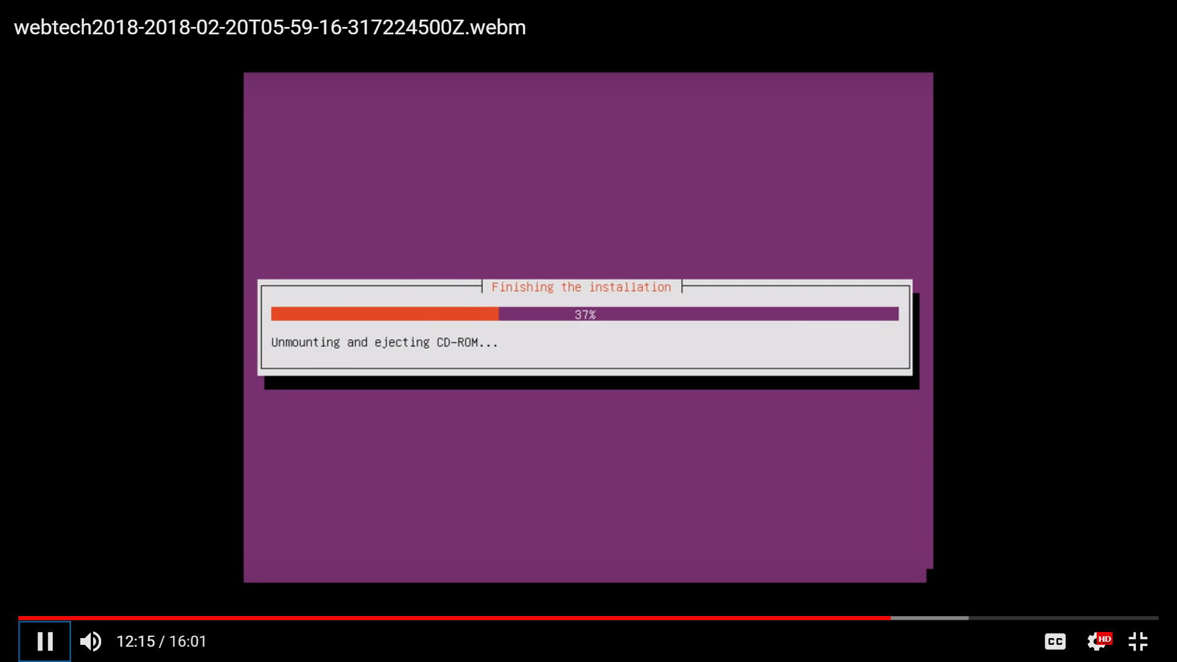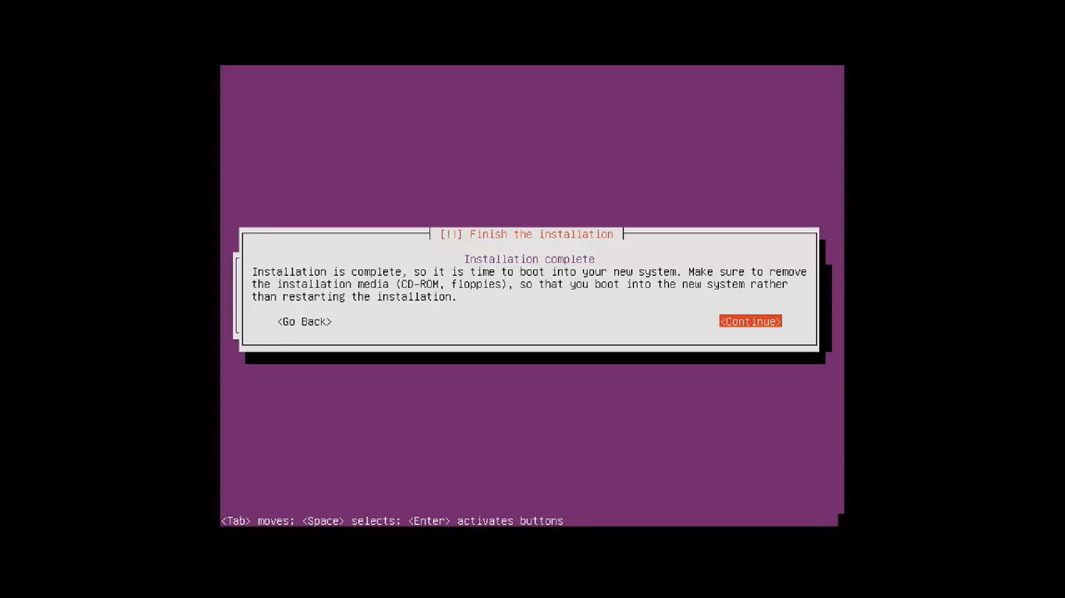

Image 3.43 Image 3.44

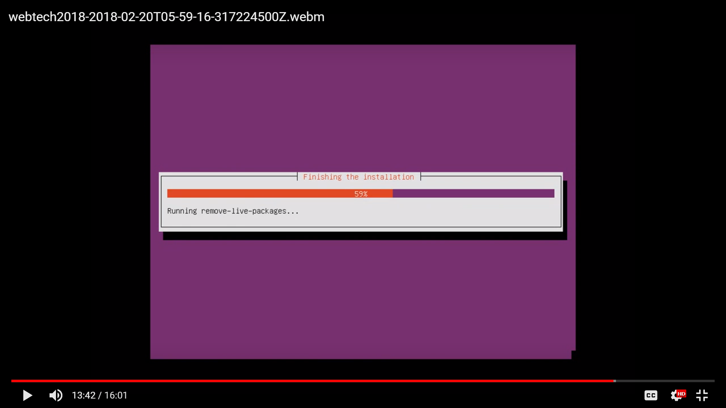

Image 3.45

* Installation is done.
* Choose ubuntu.

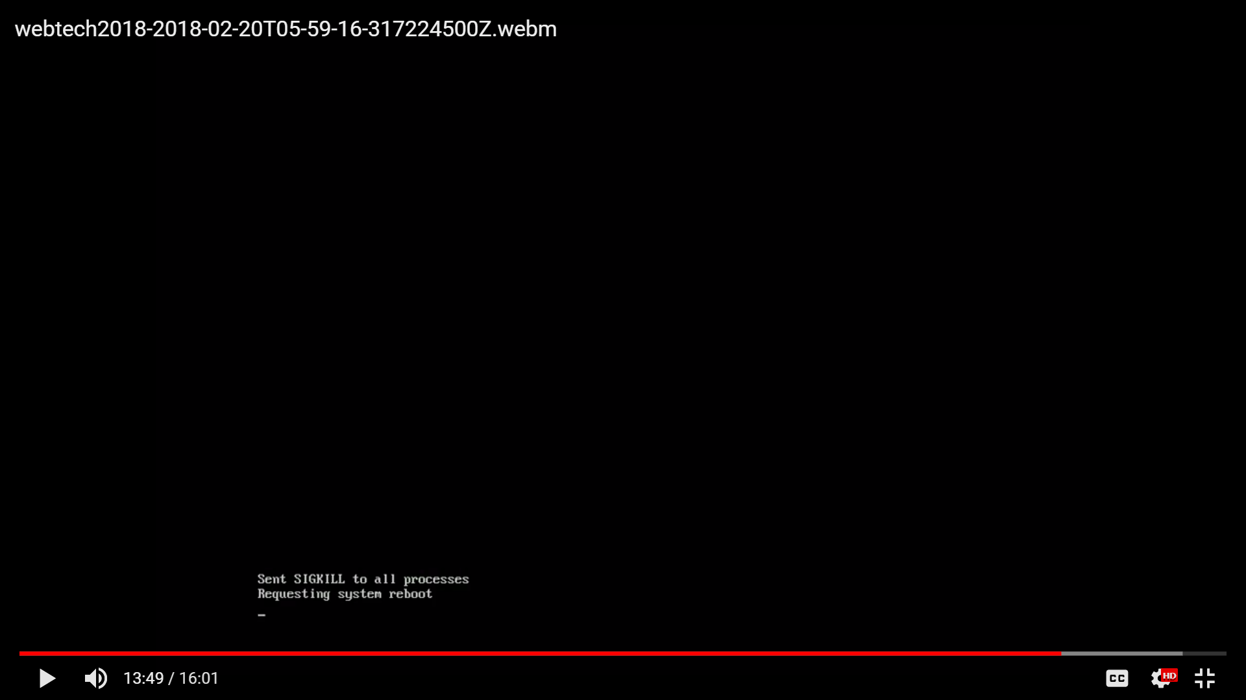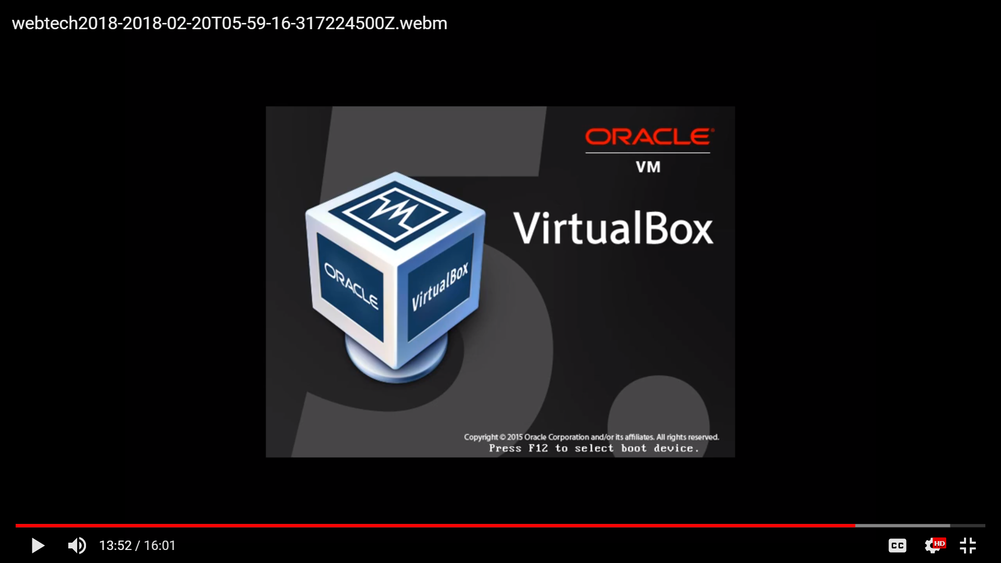

Image 3.46 Image 3.47

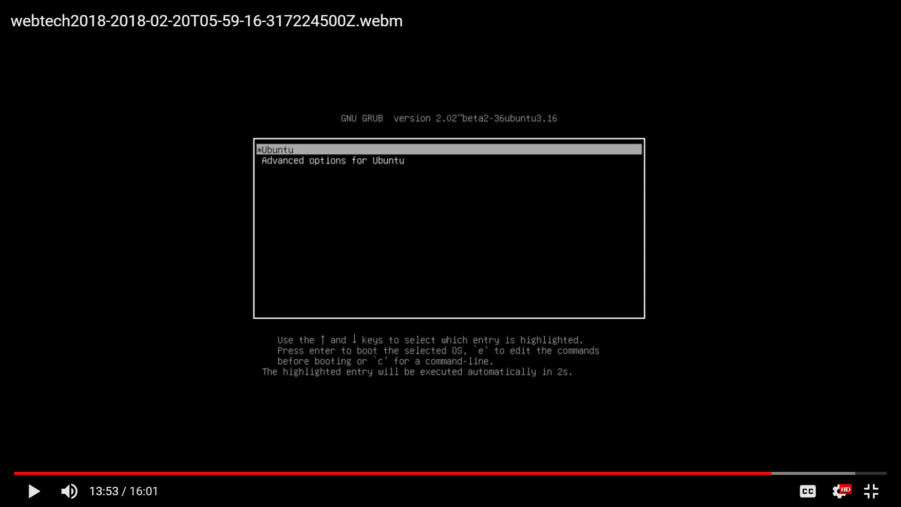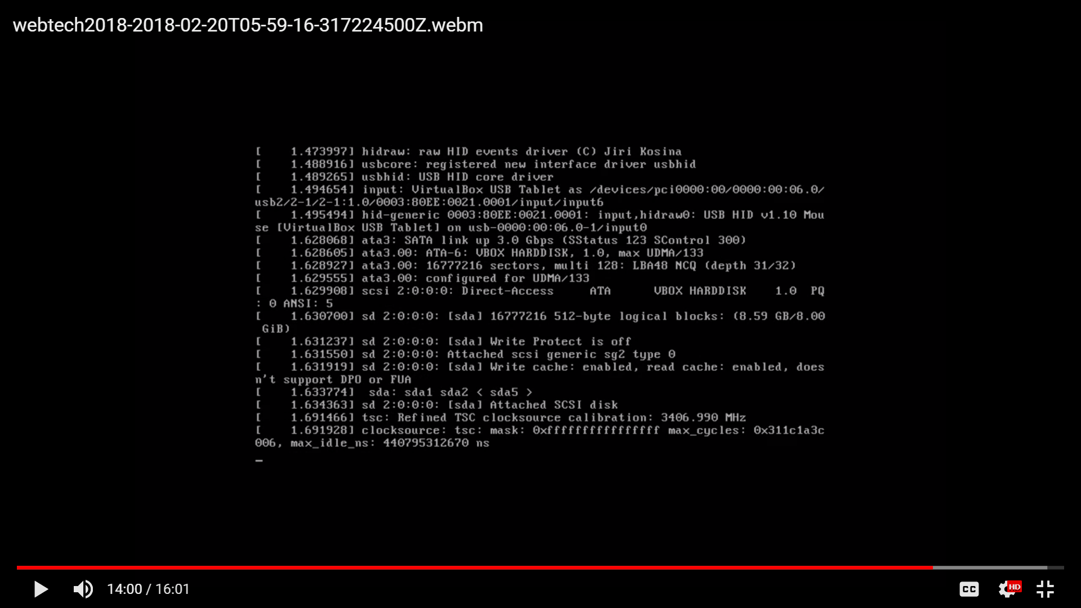

Image 3.48 Image 3.49

* Log in.

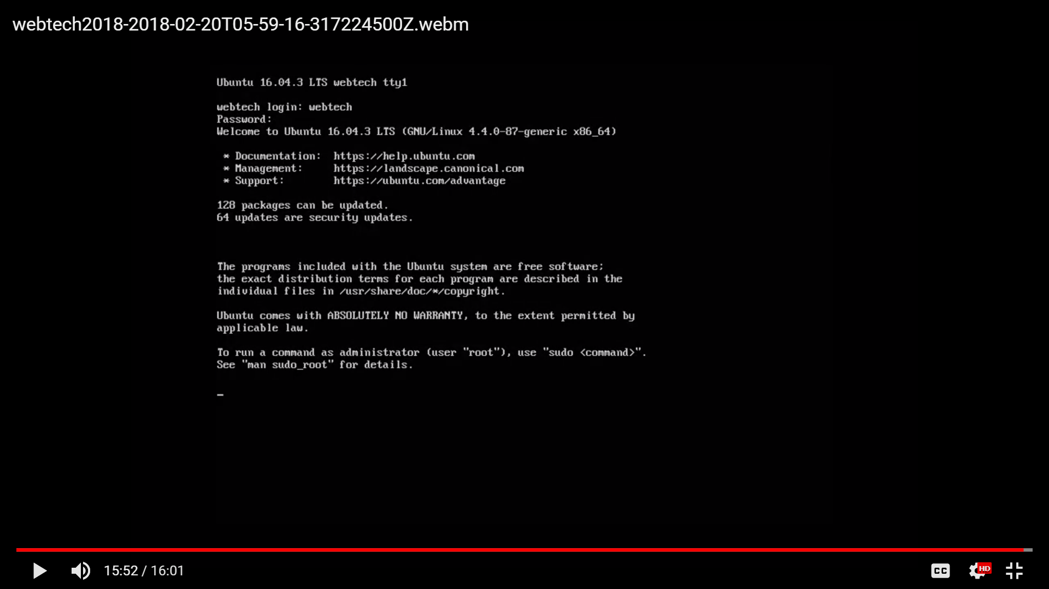

Image 3.50